PI.PO.
PING PONG WITHOUT FRONTIERS

PI.PO.
PING PONG WITHOUT FRONTIERS

SOMMARIO

SOMMARIO 2
BRIEF SUMMARY 3
MAPPING OF TERRITORIAL DATA 6
MAPPING OF POLICY AND REGULATIONS 9
STAKEHOLDER MAPPING 10
MAPPING OF GOOD PRACTICE 11
SWOT ANALISYS: STRENGHTS, WEAKNESSES, OPPORTUNITIES, THREATS 20
INTERVIEW SCHEME 25

BRIEF SUMMARY

COORDINATOR: Sport Senza Frontiere ONLUS (SSF)
Non-profit organization founded in Italy in 2011 with the aim of making sport accessible to everyone, especially to children and young people who are vulnerable to risk of poverty and marginalization. The implementation of its mission consists in the implementation of sport-based projects designed to promote both social cohesion between communities and social inclusion. The work of this organization takes place in Rome, Milan, Naples, Turin, Bergamo and Trento. In 2014, the SSF intervention model was recognized by CONI (Italian National Olympic Committee) as best practice in the field of sport and integration. Since 2011 SSF has provided over 1900 sports courses to its program beneficiaries who come from 42 nationalities across 29 different sports disciplines. The organization collaborates and interacts with: Sant'Edigio Community, Contrasto photo agencies and Reuters, Department of Child Neuropsychiatry of the University of Rome "La Sapienza", Faculty of Education Sciences of the University of Roma Tre, University of the Foro Italico and the Bambino Gesù Pediatric Hospital.

ITALIAN PARTNER: ASD Senigallia Table Tennis
It is the most important Italian table tennis association; it combines aspects of sports competition with social value as to create a sharing environment that is inspired by positive ideals that unite people by elevating diversity as an added value. Senigallia table tennis has been active for over sixty years and organizes sports activities both locally and nationally. At a social level, there is a known commitment in the organization and management of projects with families, young people for school recovery, well-being for the disabled, tourists in summer, the Social Services of the Municipality for the sports activities of the subjects with discomfort.

Since 2017 a network of two Italian operators made up of Sport Senza Frontiere Onlus and ASD Table Tennis Senigallia have activated a voluntary social inclusion initiative for children in socio-economic difficulties through the sport of Table Tennis, showing that active participation in the sport is essential to reduce social exclusion. The potential of this sport concerns the possibility of involving a wide target of people (children, adults, disabled) without any gender difference.

PROJECT FOREWORD
Sport activities have an efficient inclusive potential in strengthening social cohesion; they promote integration, open real perspectives for the participation of society and involve a wide target of participants of different ages, cultures and psycho-physical abilities. Sport has a potential for encouragement, union and bonding. It has a transversal nature as it plays an active role in maintaining health, vitality, education and functional behaviour. Furthermore, the practice of sport exudes a positive force in the comparison of young people, keeps them engaged and is a protective factor and a prevention of the risk associated with crime, delinquency and behavioural disorders. Table tennis is highly formative and develops agility, precision, coordination, concentration and breath; from a psychological point of view it teaches to pursue victory and accept defeat. It is also a very cheap and easy sport to practice.

PROJECT OBJECTIVES
The great opportunity and purpose of the project consist in the possibility of activating an international social support program for children in socio-economic difficulties by using table tennis as an innovative tool for social inclusion and to improve positive sociality, personal well-being and to strengthen the sense of community. The project aims to show how children in conditions of poverty can be gratified by being placed in a "safe" sport environment in a financial, physical and social way.
The specific objectives are:
- Establishing a Sport without Frontiers Observatory aimed at introducing and / or strengthening innovative tools for the management of sports initiatives for children and young people who have difficulties in practicing basic sports due to their condition of social fragility and socio-economic situation.
- Promoting a network and synergies between sports and education institutions across Europe in order to share new ideas, methods, projects and to encourage the importance of physical activity among young people.
- Strengthening the social and educational skills of instructors, coaches, managers of grassroots sports organizations.
- Strengthening the social and educational capacities of children and young people; promoting peer tutoring and education to help and support students with lower education results or at risk of social exclusion.
- Promoting a common strategy among the project partners by creating table tennis workshops, adopting a common protocol for social inclusion in sport and a code of sport ethics in order to achieve the objectives of the White Paper on sport (COM (2007 ) regarding the improvement of social inclusion and integration through sport (2010 / C 326/04) and to follow the recommendations of the EU Commission "Investing in children: breaking the cycle of disadvantage" (February 2013) and the European Parliament resolution "Reducing inequalities, especially child poverty" (2015).

SOCIAL INCLUSION EQUAL OPPORTUNITIES

GROUP
PREVENTION OF ANTI
SOCIAL BEHAVIOURS EMPATHY

TABLE TENNIS
COMMITMENT
FRIENDSHIP

CONDIVISION
SYMPHATY
PERSONAL
GROWTH

ABILITY DEVELOPEMENT
PRECISION AND COORDINATION

MAPPING OF TERRITORIAL DATA

Within the sports realities of foreign territories that could functionally adapt to the PI.PO - Ping Pong Without Frontiers project, it is necessary to frame all the territorial and demographic data that allow to obtain a specific picture regarding the problems and conditions of socio-economic hardship of the families involved. The data that must be analyzed for each location will be:

Population, 2018: Koroška region: 70.603 / Slovenia: 2.070.050
- Living conditions, income and average tax burden of families in the current year | Data for 2018:  Averrage bruto vage/person:  Koroška regiion: 1592,39 EUR  Slovenia: 1681,55 EUR  Average neto vage/person:  Koroška region: 1043,88 EUR  Slovenia: 1092,74 EUR
- Average expenses for monthly households consumption
2018 | Average per household (EUR) | Structure of allocated assets (%)
ALLOCATED ASSETS | 21360,35 | 100,00
FOOD AND NON-ALCOHOLIC BEVERAGES | 2816,99 | 13,19
ALCOHOLIC BEVERAGES, TOBACCO AND NARCOTICS | 350,67 | 1,64
CLOTHING AND FOOTWEAR | 1315,37 | 6,16
HOUSING, WATER, ELECTRICITY, GAS AND OTHER FUELS | 2736,41 | 12,81
FURNISHINGS, HOUSEHOLD EQUIPMENT AND ROUTINE HOUSEHOLD MAINTENANCE | 1123,42 | 5,26
HEALTH | 564,78 | 2,64
TRANSPORT | 4184,04 | 19,59
COMMUNICATION | 1016,06 | 4,76
RECREATION AND CULTURE | 1775,56 | 8,31
EDUCATION | 188,19 | 0,88
RESTAURANTS AND HOTELS | 1297,10 | 6,07
MISCELLANEOUS GOODS AND SERVICES | 2191,16 | 10,26
OTHER EXPENDITURE (not part of consumption expenditure) | 1800,58 | 8,43

- Reasons and causes of impediments to access to sports activities
- Social services data on childcare | Expenditures for social benefits of social protection programs for 2018 (for the whole of Slovenia):  1. Family and children - The area of family / children includes expenditure on benefits related to pregnancy, childbirth, adoption, child-rearing and maintenance of other family members (mainly wage compensation during maternity leave, child allowances and others: EUR 830 000 000  2. Expenditure on social protection 2018: EUR 10,092,000,000  - Institute of the Republic of Slovenia for Social Welfare  -Centre for Social Work
- Expenditure incurred by the Municipalities for the provided social services | SOCIAL SECURITY (INCLUDING INVESTMENTS) 155,680,818.89  Protection of the sick and disabled persons 22,684,342.34  Child and family care 7,832,641.70  Ensuring social security of socially endangered and socially excluded categories of the population 105,787,533.43  Other activities in the field of social protection 19.376.301,42
- Abandonment level of children with socio-economic disadvantage compared to sports
- Meaning of sportive activities for the territorial reality
- Reasons for abandoning compared to
- sports
Expenditure for sport in Slovenia in compare to BDP

MIZŠ - Ministry of Education, Science and Sport, LS - Local communities, FŠO - Sports Foundation

Regarding the item of meaning and value of the sporting activity and of any reasons for abandoning it, it will be possible to administer an especially created questionnaire that will quantitatively investigate the variables which are wanted to be measured with the aim to have a clearer picture of the situation so as to propose a targeted intervention.

Specifically for the PI.PO - Ping Pong Without Frontiers - project, the fundamental territorial data to be mapped in addition to those indicated above will be the following:

- Level of knowledge of sports table tennis | Primary level, recreational
b. Centers available to join the project with the acquisition of the necessary equipment | 3 suitable sport clubs

MAPPING OF POLICY AND REGULATIONS

Identify all the data in each individual pilot context that make it possible to clearly frame the policies and current regulations.
In particular, it is necessary to have this information:
- Ability to support the community at a fair level and therefore identify all forms of subsistence in force
- Presence and forms of provincial incentives
- Aid from local associations, beneficiary entities
Local community support funding sport programs
- Presence of specific regulations in force for the territory
Local rules on funding sport programs

STAKEHOLDER MAPPING

Stakeholders are all those subjects, individuals or organizations actively involved in the project actions. The interest of the stakeholder and its potential for action positively or negatively influence the execution and progress of the project initiative.

In order to identify the most suitable subjects for participation and collaboration in the project, it is necessary to keep the main target as background just like families in socio-economic difficulty and children who will be able to take advantage of the sports activity service.
Based on the level of influence that the project has on the basis of the level of influence that the stakeholder has on the setting, execution and result of the project, four categories can be identified:
- Marginal stakeholder : less power and less interest in involvement
- Institutional Stakeholder : more power and less interest in involvement
- Operative Stakeholder : less power and more interest in involvement
- Key Stakeholder: more power and more interest in involvement

Specifically for the PI.PO - Ping Pong Without Frontiers project, the identification and choice of suitable stakeholders will be identified according to specific parameters. The main interest will turn to looking for the following figures / bodies / organizations:

Data present City Municipality Slovenj Gradec

- Professional figures in sport (coaches, instructors, trainers) | All sports: 124
- Educators | Sport: 17
- Social workers | Centre for Social Work: 10
- Professional figures in healthcare (psychologist, competent doctor etc.)
- Volunteers
- Collaborating schools | Primary: 5; Secondary: 4
- External and internal trainers
- Collaborating sports organizations | sport clubs: 41, suitable for the project cooperation 3
- Collaborating non-profit organizations | sport clubs: 41
Table 3

MAPPING OF GOOD PRACTICE

Eurostat data collected since 2014 contributed to the establishment of the Save The Children report "Defeating educational poverty in Europe. According to this report, over 26 million children are at risk of poverty or exclusion in Europe. 20% of 15-year-olds in Europe live in conditions of educational poverty. In Italy, almost 39% of children are at risk of poverty or social exclusion. 12.5% ​​of children under the age of 18 find themselves in absolute poverty. Of these, 43% have never played sports. These data indicate that poverty is a daily reality for many people in European societies.

In the European Union, child poverty has been understood as a complex multidimensional phenomenon. This is not just a shortage of economic resources; deprivation also concerns socio-educational development, participation in sports activities and social inclusion. Health, education, nutrition, care, protection and participation are negatively mined domains in realities of poverty.
In addition to the factor of socio-economic difficulties, there are also other variables that limit good educational and sports practice, such as motivation, environment, participation and flexibility.

At an educational and sporting level we can highlight the following practices:

- To transmit information on the health benefits of physical movement
- To create a setting of social inclusion that favors both relationships and teamwork
- Reinforce proactive behaviours and adequately intervene through suitable professional figures where emotional and behavioural difficulties can be observed
- To transmit the sense of “doing together” and “reaching a goal”
- To create a positive context of protection, training, education and fun
- Conveying the typical values ​​of table tennis sports, such as: discipline, respect for the rules, coexistence with one's own characteristics, functional interaction, alliance and movement.

Good practices for Slovenia.
Presente3d are two good practices dealing with sport for children and youth. One was initiated on institutional level as a national project, the other was initiated by NGO and focused on socially disadvantaged children.
On institutional level
Zdrav življenjski slog (Healthy lifestyle)
[Date]  2010-2018 | [Authors]  Prof. dr. Strel, Janko et all
Location /geographical coverage | Program was implemented in all 12 regions in Slovenia.
Target Audience | School children
Objectives | Provide all interested pupils for at least two hours of additional free sports activities, which together with a sport education represents 5 hours a week (sports education + ZŽS program)..
Introduction | In Slovenia, the physical activity and physical fitness of children and youth is better than the situation in most European countries, but even Slovenian children are not immune to negative changes in modern lifestyles and also have been able to detect negative trends in development for several years. Desirous of reversing the downward trend of physical fitness in Slovene children as soon as possible, a healthy lifestyle program (ZŽS) was conceived. Program became the largest intervention program in Slovenia in the field of health and social inclusion, which is pursued through sport engagement.  Thanks to the program Slovenia is the first in Europe, which has managed to reverse the trend of decreasing physical abilities in the primary school population. It was achieved with a daily, regularly, and qualitatively structured sport workout, which is the only activity that can neutralize many of the negative consequences of today's, predominantly sedentary, lifestyle and inadequate dietary habits of children and youth.  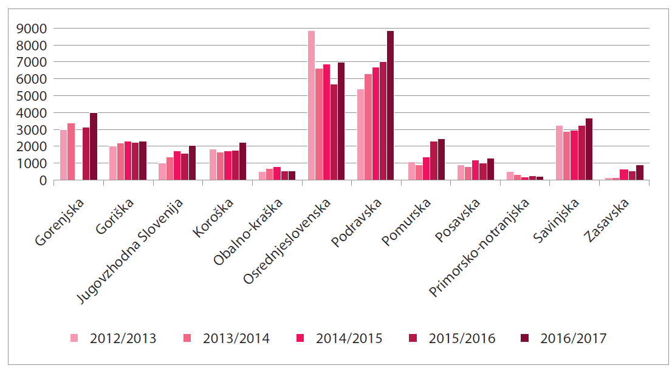  Graf 1 Number of children in the program ZŽS by statistical regions after school years  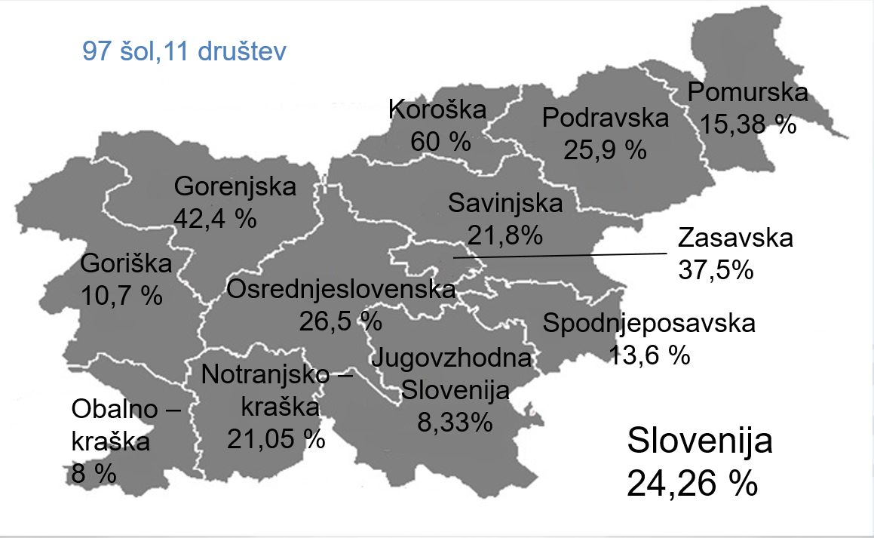
Stakeholders and Partners | Final beneficiaries of program are children age 6-15 years – primary school.  - Partners of the project were:  - 97 schools throughout Slovenia – implementation of the program  - Slovenian Faculty of sport, expert support, and analytical research  - Slovenian Sport Institute Planica, project coordinator  - Ministry of education, science, and sport, - cofinancer  - Sport clubs throughout Slovenia  - Europian socail fund -financer
Methodological Approach | The aim of the ZŽS program is to provide all interested pupils for at least two hours of additional free sports activities, which together with a sport education represents 5 hours a week (sports education + ZŽS program). The ZŽS program takes place during the course of the school and during the course of the days of leisure and does not interfere with the implementation of the school's compulsory educational program. In the context of the ZŽS program, children are represented at least 12 sports, which are held in the hall, outdoor sports areas or in the natural environment. They are also represented to urban sports and in more detail at least 3 sports present on local level, where elementary school is located, in cooperation with local sports clubs. In this way, pupils learn more intensively with the content of different sports and, for the sake of good knowledge of the possibility of sporting participation in the local environment, they include in the sport clubs, thus spreading awareness of healthy lifestyle also to other age groups (parents, grandparents,...).  The program allows all children who express their desire for additional physical activity to be included providing the opportunity to participate regardless of sex, age, race, economic status, state of movement, etc. It is worth noting that we have managed to include children who represent potential for social exclusion (this population mainly consists of children with sub-average physical abilities and overweight, children with special needs, children with low self-esteem, children with lower family-economic status and children who have diseases of modern time, such as diabetes ,...).
Impact | Changes in pupils "healthy lifestyles" are greater, especially when analysing positive changes in the development of aerobic endurance, coordination of motion and muscle strength of the shoulder ring and hands. The analysis also shows that the effects of the development of mobility potentials are more evident in boys than girls  In the case of boys, more than 10% increase in the number those who don't use computers and for the girls same goes for more than 20%.  More than double the number of schoolboys who don't even watch television. In 2017, 21% of these were recorded, and more importantly, the number of those who watched TV more than 5 hours was halved. Schoolgirls are watching a little more than students. The number of schoolgirls who did not watch the TV was in 2011 – 2017 significantly increased, almost doubled, and for three times the fewer are those schoolgirls who watch TV for more than 5 hours.  Nation-wide reversed trends of obesity and physical fitness was achieved.
Lessons learned | Significant positive changes in the physical fitness of pupils and especially schoolgirls were achieved.  The recommendations of medicine only for more physical activity are inappropriate for today's time and require a redefinition of the recommended physical activity needed for a physical fitness, which will result in reduction of the chronic morbidity of the population of different age groups, including children and youth.  Children and adolescents living in a more favourable economic environment thus increase the difference between themselves and those living in a less favourable environment. Of concern, however, is the fact that the proportion of those lagging behind in the physical fitness development is also increasing faster than those progressing.
Replicability and/or up-scaling | Outcomes of the project are available on web platform results were presented through various scientific articles thus giving the basis for implementation of the project in other environments.
Conclusion | In all aspects project was a success, number of active schoolchildren during the project was significantly higher and analyses also showed higher educational success of children involved in project.  Taking into account the decrease in the number of long-term sick children by 30% in seven years, a significantly better quality of lifestyle of children, and their parents was achieved.
Contact details | What is the address of the people or the project to contact if you want more information on the good practice?  info@sport.si
URL of the practice | Where can one find the good practice on the Internet?  https://www.zsrs-planica.si/zdrav-zivljenjski-slog/
Related Web site(s) | What are the Web sites of the projects under which the good practice was identified and reproduced?  https://www.sportmladih.net/programi_som/zdrav_zvivljenjski_slog  https://www.zsrs-planica.si/zdrav-zivljenjski-slog/
Related resources that have been developed | What training manuals, guidelines, technical fact sheets, posters, pictures, video and audio documents, and/or Web sites have been created and developed as a result of identifying the good practice?  Yearly research analyses  Yearly conferences, seminars

NGO initiated
Pomežik soncu, Wink to the sun®
Date  since 1999 | Author  Association of Friends of Youth of Slovenia
Target Audience | Good practice is devoted children from socially endangered families
Objectives | The objectives of the humanitarian programme of the Sun Blinks® are:  - Provide as many children a completely free holiday,  - The inclusive creation of groups prevents the social exclusion of children from socially endangered families (together children from different social background),  - Children from socially endangered families, which are due to the financial distress of parents, not only disadvantaged, but are often reflected in their physical and psychological health, to enable 7 or 10 days of carefree, relaxing, creative and active holidays in the company of peers.
Location/Geographic Coverage | The programme is carried out in the field of Slovenia, which counts about 30 organizers of resorts that are included in the ZPMS.
Introduction | The main purpose of the “Wink to the Sun® is the collection of funds for the holidays of children from socially endangered families. The Program started 1999 and has been running for 21 years. Activities for the implementation of the programme are running all year round, starting with the preparation of the activity plan for the acquisition of sponsorship and donor funds. Most of the activities for fundraising takes place from April to July. In April we prepare an internal call for organisers of resorts. In the summer months holidays take place, and in April and November, professional training of pedagogical leaders are carried out. The evaluation of the implementation of the programme is carried out in October when, on the basis of the reports of the organisers of the resorts, we prepare a final report on the holidays addressed by the National Committee for Leisure and Flight, later the management board ZPMS and finally adopted by the ZPMS assembly.  Program of the holiday activities contains social skills, and sport is most common tool of delivery.
Stakeholders and Partners | The target group of the programme are children from socially endangered families. There are over 45,000 children living below the poverty threshold. Many families have no funds nor for basic survival, let alone for an appropriate holiday. The key feature of children from socially endangered families (between 6 and 15 years old) is that they take holidays with their peers from general public (self-paying), which are taking holidays, according to the principle of inclusion so there's no distinction between children. Thus, our partners in the implementation of the members of the ZPMs, who, in cooperation with School advisory services, pediatricians and social work centres, are preparing proposals for holidays. Funds to implement the program are provided by collecting funds that involve larger donors and sponsors, public tenders, and also individuals.
Methodological approach | ZPMS has an extraordinary tradition in the field of child-holidays and has been performing for over 65 years. Our service providers have 15 resorts (10 by sea, 5 in the Hills – a total of 2,500 beds), specially built and arranged for the rest of the children. In 1998, the ZPMS survey was conducted. The findings showed that donors are willing to donate for the free holidays of children from socially endangered families. Therefore, in 1999 ZPMs a campaign of “Wink to the Sun®, was introduced and which encountered a major response. From then on, we've been doing it every year, and last year's action was 20. Anniversary. During this time, we updated the means of fundraising, introduced programme evaluations, identified eligibility rules, introduced education to educators and pedagogical leaders and set the conditions for the selection of organisers of resorts. Each year we prepare an internal call for organisers of resorts that can be run for funds collected by ZPMS for free holidays for children. Every year we interview all the children at the resorts – we ask them what they liked, what they would change, what they missed... , because we want children to spend an unforgettable holiday with us.
Impact | The impact of the Wink to the Sun ® on children from socially endangered families is positive, since in the annual evaluation The children's responses are given to them that they liked to be too short and that they would also like to attend the next year. The aim of the programme is to contribute to the improvement of the health situation of children from socially endangered families and to mitigate the social distress of these families during the holiday season, which we also succeed during the year. In the evaluation of children, we do not distinguish by sex. The social status of children is assimilated to other children during the year, as they lie in the same groups, according to the principle of inclusion.
Innovation | Parents recognize the program as a traditional oen. It presents them with the possibility to allow their children, despite the financial inability to pay for the holiday, to provide free vacations. Professionally, it is justified that the holiday for child development is an extremely important period. This is the time when children do what they look forward to, develop their talents, abilities and acquire important experiences in the sociability of peers. Especially this applies to children living in families in social distress. These children have on organized vacations not only adequate care, but also many incentives for activity, creativity and building their own positive self-image.
Success factors | The conditions which must be fulfilled for the implementation of the wink of the Sun®:  - Successfully prepared and implemented the fundraising campaign,  - An internal call for selection of organisers of resorts,  - Education of pedagogical leaders at resorts,  - Registration of children eligible for financing holiday,  - The execution of program during the summer months,  - Evaluation of the programme,  - A report on the program.
Constrains | As organizers and performers of the Wink to the Sun® We encounter a lack of financial resources for implementation, as the needs of children from socially endangered families are increasing every year. Only children who correspond to the criteria for the free holiday of children from socially endangered families can attend a complete free holiday. The organizers of the resorts at ZPMS also organise other types of resorts and activities, so that parents talk about other leisure opportunities.
Lessons learnt | With ZPMS , every year he wants to collect more donations and in this way send to a holiday more children. With the tradition, visibility and transparency of the programme, we have achieved through these years that donors, sponsors, co-Financers, partners and parents trust us. The holiday programs are upgraded annually and we ensure that the service providers are appropriately trained to make the children feel good at the resorts. The ongoing evaluation of the programme convincates us that the holiday is needed, as children are alleviating health indications and currently improving social status, children are also learning new skills at the resorts.
Replicability and/or up scaling | Pheadings Wink to the Sun® is a protected trademark of the Association of Friends of Youth of Slovenia and protection applies to the area of the Republike of Slovenia. Only members of THE ZPMS are Invited to participate in the programme.
Conclusion | Pheadings blinks the Sun® is well recognized in society, since it has been successfully implemented for the 21st year. They are identified by donors and sponsors, known by the media, known by the parents, who send children to the flight, and in the end they also know the children who are working through the program.
Contact details | Breda Krašna, Secretary general of the ZPMS  breda.krasna@zpms.si
URL of the practices | www.zpms.si
Related web Sites (s) | Good practice has been identified and replicated on the websites of our organisers of resorts, e.g.  https://zpm-mb.si/humanitarnost/pomezik-soncu/  http://www.zpmvic.si/socialno-humanitarni-programi/  https://mdpm.si/zpms-tudi-letos-z-akcijo-pomezik-soncu-zbira-sredstva-za-letovanja-otrok/
Related resources that have been developed | Logotype program:  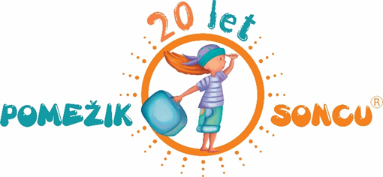  Posters of the program:  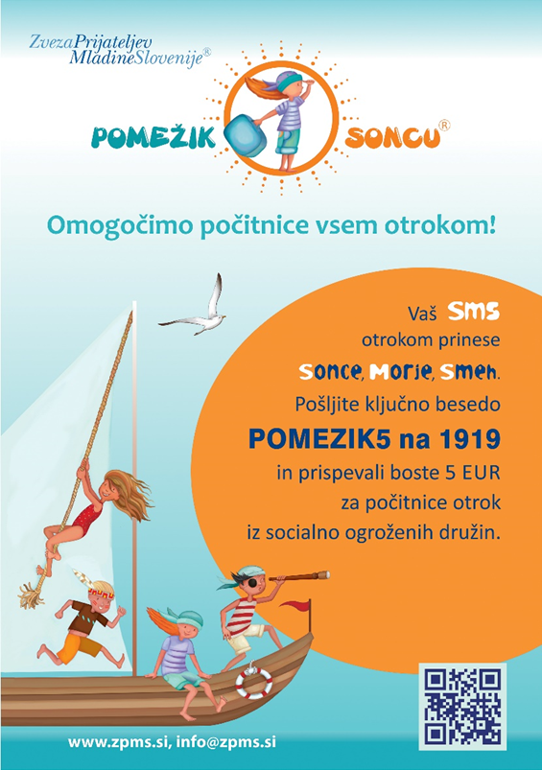

Specifically, we will investigate the presence of the following tools to implement good practices both at an educational and sports level:

- Associations that give incentives to families with socio-economic disadvantages | Centre for Social Work,  Sport union Slovenj Gradec,  Zavod APGA  Sonček – Cerebral Palsy Association, day center
- Discount coupons and discounts for families with economic disadvantage | /
- Projects that could be associated with collaborations | /
- Networks that work to help implement good practices | /
Table 4

SWOT ANALISYS: STRENGHTS, WEAKNESSES, OPPORTUNITIES, THREATS
This analysis allows to frame the external and internal factors that act positively or negatively on the implementation of the project. In particular we talk about: strengths, weaknesses, opportunities and threats.

The SWOT matrix is the graphic representation on which to focus the salient points related to the project. It consists of four squares:
- Internal factors on top (strenghts, weaknesses)
- External factors below (opportunities, threats)
- Positive elements on the left (strenghts and opportunities)
- Inevitable internal and external obstacles on the right (weak points and threats)
There are no weak points and threats that cannot be transformed into salient features and opportunities.

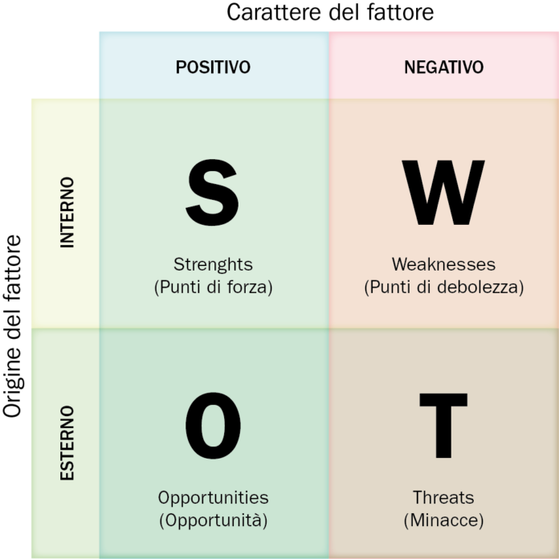

Strength and weak points to look for in a project are:

SRENGHT POINTS | WEAK POINTS
- Recognizable brand | - Little consistency with the guidelines of the project and its objectives
- Quality of the offered services | - Little collaboration in the team of operators
- Good reputation | - Little participation or disinterest of the target
- High recipient satisfaction rate | - Loss of motivation
- Quality of assistance | - Negative synergy
- Competent operational team | - Mistrust
- Clear and consistent proposals with the target’s expectations | - Absence of aids and incentives
Table 5

The opportunities and threats to look for in a project are:

OPPORTUNITIES | THREATS
- Market offers | - Bureaucratic difficulties
- Possibility of external collaborations | - Political instability
- Emotional growth | - Hostile environmental context
- Training opportunities | - Distrust and negative synergy
- Favorable environmental context | - Limited forms of subsistence
- Growth opportunities
Tabella 6

By applying the Swot analysis to the PI.PO Project, the following variables could be hypothesized to be investigated through an interview model specifically built that measures the level of incidence of each variable:
- Level of collaboration between the active operators of the project
- Motivation level of children/young people for sports
- Level of participation of children/young people in sports
- Social inclusion level
- Type of synergy
- Level of opportunity for emotional growth
- Level of training opportunities
- Psycho-phisical activation level
- Level of collaboration by families
- Subsistence forms and incentives
- Environmental context
Table 7

INTERVIEW TEMPLATE

INTRODUZIONE

The aim of this research-intervention is finding the sports realities that can functionally adapt to the PI.PO - Ping Pong Without Frontiers project. In particular, research is being carried out on those organizations which, both structurally and educationally, can promote the performance of table tennis sports by strengthening social inclusion, the support of young people living in situations of socio-economic difficulty, and the development of psycho-physical health.
The research is limited to the mapping of one or more territorial sports centers in order to evaluate whether these structures have potential bases to be inserted in a functional way to the project or not. It is therefore a matter of analyzing the material, economic, educational, social and existing network aspects, focusing above all on the benefits that would have the users of the proposed project with the aim to emphasize the values ​​of social inclusion and active participation for all young people, especially for those who experience poverty.

INTERVIEW SCHEME

DENOMINAZIONE ORGANIZZAZIONE SPORTIVA/CENTRO SPORTIVO
ORIGIN AND ITS FUNCTIONALITY OVER TIME
MISSION
TERRITORIAL DISTRIBUTION | Vicinanza con:  - Scuole  - Centri di aggregazione sociale  - Case famiglia  - Centri diurni  - Parrocchie  - Centri giovanili  - Spazi aperti  - università
ORGANIZATION MANAGERS
STRUCTURAL ORGANIZATION | - Grandezza palestra  - Numero di tavoli da ping pong installabili  - Presenza di spogliatoi e docce
SPACES FUNCTIONALITY | - Possibility of organizing sports activities  - Possibility of organizing workshops  - Possibility of organizing aggregation and leisure moments  - Proximity of open spaces (parks, lawns, etc)
TEMPORAL ORGANIZATION STRUCTURE | - Weekly opening hours  - No. Of weekly training hours dedicated to the youth sector  - Presence of summer and holiday closings  - Annual and daily average frequency of children/adolescents/young people involved
INVOLVED STAFF | - No. of instructors  - No. of educators  - No. of volunteers  - No. of animators  - No. of other collaborators
INVOLVED RECIPIENTS | - No. children (6-12)  - N. adolescents (12- 18)  - N. young people > 18  - Male/Female prevalence  - Nationality prevalence  - Socio/economic condition prevalence
SUPPORT NETWORK | - Public bodies  - Non-profit associations  - Social cooperatives  - Foundations  - Religious bodies  - Private associations
BUDGET | - Annual expenses  - Annual expenses dedicated to the youth sector
FUNDING | - Sponsors  - Donations  - Charity events  - Provinces
EDUCATIONAL OPPORTUNITIES | - Possibility of welcoming individuals with socio-economic difficulties  - Equal opportunity offer  - Possibility of moments of aggregation and social inclusion  - Possibility of training moments
SPONSORSHIP | - Website  - Advertising spaces  - Social networks  - Flyers  - Paid training activities
POSSIBLE RISKS
FUTURE PERSPECTIVES
CONTACTS | - Telephone  - Email  - Fax

