**PI.PO.**

**PING PONG WITHOUT FRONTIERS**

**PI.PO.**

**PING PONG WITHOUT FRONTIERS**

**SUMMARY**

**SUMMARY** 2

BRIEF SUMMARY 3

PROJECT FOREWORD 3

PROJECT OBJECTIVES 4

MAPPING OF TERRITORIAL DATA - TRENTO 6

TERRITORY ECONOMIC CONDITIONS 9

MAPPING OF POLICY AND REGULATIONS 12

STAKEHOLDERS MAPPING 13

MAPPING OF GOOD PRACTICES 15

ANALISI SWOT: STRENGHTS, WEAKNESSES, OPPORTUNITIES, THREATS 17

# BRIEF SUMMARY

COORDINATOR: Sport Senza Frontiere ONLUS (SSF)

Non-profit organization founded in Italy in 2011 with the aim of making sport accessible to everyone, especially to children and young people who are vulnerable to risk of poverty and marginalization. The implementation of its mission consists in the implementation of sport-based projects designed to promote both social cohesion between communities and social inclusion. The work of this organization takes place in Rome, Milan, Naples, Turin, Bergamo and Trento. In 2014, the SSF intervention model was recognized by CONI (Italian National Olympic Committee) as best practice in the field of sport and integration. Since 2011 SSF has provided over 1900 sports courses to its program beneficiaries who come from 42 nationalities across 29 different sports disciplines. The organization collaborates and interacts with: Sant'Edigio Community, Contrasto photo agencies and Reuters, Department of Child Neuropsychiatry of the University of Rome "La Sapienza", Faculty of Education Sciences of the University of Roma Tre, University of the Foro Italico and the Bambino Gesù Pediatric Hospital.

ITALIAN PARTNER: ASD Senigallia Table Tennis

It is the most important Italian table tennis association; it combines aspects of sports competition with social value as to create a sharing environment that is inspired by positive ideals that unite people by elevating diversity as an added value. Senigallia table tennis has been active for over sixty years and organizes sports activities both locally and nationally. At a social level, there is a known commitment in the organization and management of projects with families, young people for school recovery, well-being for the disabled, tourists in summer, the Social Services of the Municipality for the sports activities of the subjects with discomfort.

Since 2017 a network of two Italian operators made up of Sport Senza Frontiere Onlus and ASD Table Tennis Senigallia have activated a voluntary social inclusion initiative for children in socio-economic difficulties through the sport of Table Tennis, showing that active participation in the sport is essential to reduce social exclusion. The potential of this sport concerns the possibility of involving a wide target of people (children, adults, disabled) without any gender difference.

# PROJECT FOREWORD

Sport activities have an efficient inclusive potential in strengthening social cohesion; they promote integration, open real perspectives for the participation of society and involve a wide target of participants of different ages, cultures and psycho-physical abilities. Sport has a potential for encouragement, union and bonding. It has a transversal nature as it plays an active role in maintaining health, vitality, education and functional behaviour. Furthermore, the practice of sport exudes a positive force in the comparison of young people, keeps them engaged and is a protective factor and a prevention of the risk associated with crime, delinquency and behavioural disorders. Table tennis is highly formative and develops agility, precision, coordination, concentration and breath; from a psychological point of view it teaches to pursue victory and accept defeat. It is also a very cheap and easy sport to practice.

# PROJECT OBJECTIVES

The great opportunity and purpose of the project consist in the possibility of activating an international social support program for children in socio-economic difficulties by using table tennis as an innovative tool for social inclusion and to improve positive sociality, personal well-being and to strengthen the sense of community. The project aims to show how children in conditions of poverty can be gratified by being placed in a "safe" sport environment in a financial, physical and social way.

The specific objectives are:

Establishing a Sport without Frontiers Observatory aimed at introducing and / or strengthening innovative tools for the management of sports initiatives for children and young people who have difficulties in practicing basic sports due to their condition of social fragility and socio-economic situation.

Promoting a network and synergies between sports and education institutions across Europe in order to share new ideas, methods, projects and to encourage the importance of physical activity among young people.

Strengthening the social and educational skills of instructors, coaches, managers of grassroots sports organizations.

Strengthening the social and educational capacities of children and young people; promoting peer tutoring and education to help and support students with lower education results or at risk of social exclusion.

Promoting a common strategy among the project partners by creating table tennis workshops, adopting a common protocol for social inclusion in sport and a code of sport ethics in order to achieve the objectives of the White Paper on sport (COM (2007 ) regarding the improvement of social inclusion and integration through sport (2010 / C 326/04) and to follow the recommendations of the EU Commission "Investing in children: breaking the cycle of disadvantage" (February 2013) and the European Parliament resolution "Reducing inequalities, especially child poverty" (2015).

SOCIAL INCLUSION EQUAL OPPORTUNITIES

GROUP

PREVENTION OF ANTI  
 SOCIAL BEHAVIOURS EMPATHY

TABLE TENNIS

COMMITMENT

FRIENDSHIP

CONDIVISION

SYMPHATY

PERSONAL GROWTH

ABILITY DEVELOPEMENT

PRECISION AND COORDINATION

# MAPPING OF TERRITORIAL DATA - TRENTO

The Autonomous Province of Trento, as of 1 January 2019, has 541 098 inhabitants of which 118 288 residents in the Municipality of Trento.

The demographic reading by age group reports that:

- children from 0 to 14 years are 14.4% of the population;

- young people in the 15-29 age group represent 15% of the population.

The foreign resident population constitutes about 11% and comes largely from Europe (in particular Romania, Albania, Moldova and Ukraine) followed by Asia (Pakistan in strong increase), Africa, South America, also confirming to have a very young demographic.

In Trentino, family income is higher than the Italian average but the distance between the richest and the poorest has widened. Situations of poverty are evident: 5% of the adult population claims to have many economic difficulties and 8% of families are in conditions of relative poverty (Department of Health and Social Policies - Trentino Salute).

According to data from Openpolis, already in 2019, among the large regions of the north-west, the Province of Trento, with 20.6%, is the one with the highest percentage of poverty risk and / or social exclusion.

According to the latest available data, in Trentino individuals in conditions of relative poverty are 9.6% of the population. This figure is also lower than the national average (equal to 15%) but higher than in the large northern regions such as Lombardy (8.6%) and Emilia-Romagna (6.8%). By relative poverty we mean people and families in conditions of economic and social hardship compared to the majority of the population.

According to the Institute of Statistics, a family unit of a person who spends up to 657.05 euros per month, is poor in relative terms, a family of two who spends no more than 1,095.09 € per month, a family of three that spends a maximum of € 1,456.47 per month, a nucleus of four with an expense of under € 1,785 per month, a family of five that spends a maximum of € 2,080.67 per month , a family of six with a monthly expense of € 2,365.39, a family of seven with an expense of € 2,628.22 a month.

The relative poverty lines therefore indicate families who cannot afford anything but essential expenses. Among them are those who are in arrears in paying bills, rent, mortgages or other types of loans, families who cannot bear an unexpected expense such as health care, families who cannot afford holidays away from home. And then there are the cases of even greater difficulty, as told by Caritas of Trento (particularly active in supporting people in difficulty) of those who lose their jobs at the age of fifty, those who fall into addiction to substances or gambling, the immigrant who does precarious jobs waiting for the residence permit

In recent years there has been an important demographic increase due, above all, to the arrival of foreign workers and major transformations concerning family units: nuclei composed of only one person represent 38% of the families of the Municipality of Trento, 27, 9% are composed of two people, 16.9% of three, 13.7% of four members, 3.5% of five or more members; the increase in working mothers, single-parent families with dependent children (following separations and divorces), the difficult management of working times and life times, a certain economic and employment precariousness, the progressive decrease in the support of the extended family .

LEVEL OF EARLY ABANDONMENT OF SPORTS ACTIVITIES IN THE TERRITORY

At the Italian level, Istat-Coni data show that in the 11-14 age group, 66% of boys play sports, compared to 48% of girls; but these percentages have already dropped to 56% and 39% respectively in the 15-17 age group, to decrease again to 46% and 27% in the 18-19 age group. In sport, some young people leave before starting a real sporting career: some leave a discipline to undertake a different one, others abandon the competitive dimension to move on to diversified and non-competitive motor activities, perhaps carried out independently; still others, finally, leave sport, but with it also the motor dimension in general, and make completely different choices (often sedentary) for their free time. A "dropout" is generally defined as the premature abandonment of a sports career, that is, before an athlete has been able to fully express their potential (Bussmann, 2004). According to Coni data, in Trentino, 92% of elementary school-age children play sports but with the transition from middle to high school, 30-40% of very young Italians say goodbye to tracksuits and sneakers. From 12-14 years up to 40% stop doing sports, with much higher peaks among girls. A recent CONI territorial survey carried out in 2019 confirmed this trend by identifying some additional critical factors which are set out below.

|  |  |
| --- | --- |
| Factors associated with dropout in sports Investigation  SURVEY SPORTS ABANDONMENT  Students of the Province of Trento - CONI TN - 2019 | |
| **Socio-ecological** | -low parental education  -failure to contact a specialized physical education instructor during school;  -insertion in particularly strict and demanding schools,  -high dedication to study  -poor engagement in extracurricular activities,  -poor management of time and commitments; |
| **Personal** | -motivational orientation dependent on extrinsic and contextual factors;  -laziness;  -negative attitude towards sporting activity;  -lack of fun;  -sense of insecurity about one's abilities and control of one's behaviour; |
| **Psicosocial** | -family pressures;  -having friends who do not attend the same sporting contexts (especially for children);  -parents who were high-level athletes during their youth;  -difficulty in relating with peers;  -reduced perception of support for autonomy by the coach and parents authoritarian style a lack of openness to dialogue on the part of the coach; |
| **Related to the sports activity itself** | -monotony of training;  -competitive anxiety  -exasperated levels of competitiveness;  -high costs;  -inconvenience of schedules;  -inconvenience in reaching sports facilities;  -low amount of one-to-one workouts with your coach; |

(<https://www.itcc.it/psicologia/abbandono-pratica-sportiva/>)

A Below are some graphs regarding the levels of abandonment from sports in Trentino and the reasons for abandonment based on the CONI survey conducted through questionnaires submitted to 330 Trentino students (from 12 to 18 years) of the year 2019:

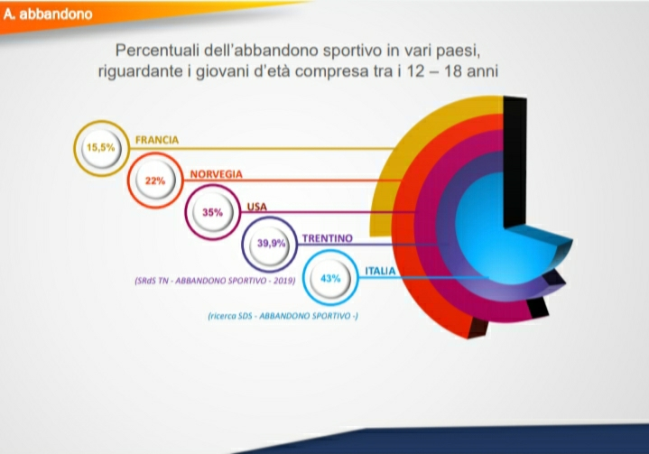

**Level of abandonment of sports practice in Trentino compared to Italy and other countries in the world.**

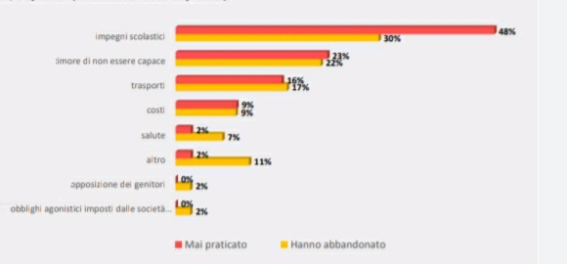

**Reasons compared to those who have abandoned, never approaching the desired sporting practice.**

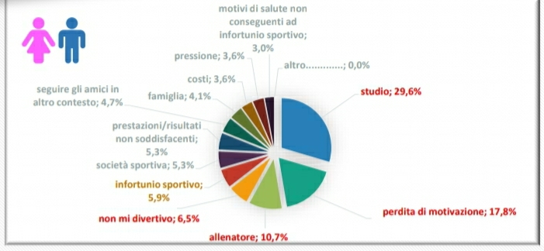

**Motivation for abandoning sports practices**

# TERRITORY ECONOMIC CONDITIONS

The Italian Caritas report, published on the occasion of the World Day to Fight Poverty (October 17, 2020), seeks to return a photograph of the serious economic and social effects of the current health crisis linked to the Covid-19 pandemic. The Bel Paese recorded a marked decline in GDP in the second quarter of 2020, the most worrying since the start of the historical series (-12.8%); employment undergoes a severe shock, registering a decrease of 841 thousand employees compared to 2019; In addition, the unemployment rate decreases in favor of a noticeable surge in inactive people (in this time, therefore, people stop looking for a job). Therefore, the time of a serious economic recession seems to be looming, which becomes fertile ground for the birth of new forms of poverty, just as happened after the crisis of 2008. And the data of the Caritas listening centers go in this direction: from one year to the next the incidence of the "new poor" goes from 31% to 45% (almost one in two people who turn to Caritas for the first time). In particular, the weight of families with minors, women, young people, Italian households and people of working age increases; on the other hand, the serious marginality falls. Therefore, we can see the hypothesis of a new phase of "normalization" of poverty, as the effect of the 2008 economic shock. What makes the difference, however, compared to twelve years ago is the point from which we start: in Italy in the pre-pandemic (2019) the number of absolute poor is more than double compared to 2007, on the eve of the collapse of Lehman Brothers

Analyzing the situations of difficulty that characterized our country on the eve of the emergency somehow helps to focus on the situations and faces of those who, today more than ever, find themselves living a situation of greater disadvantage. It is in this perspective that in our opinion it is important to consider the Istat data on absolute poverty (published last June) relating to the situation in 2019. In pre-Covid Italy, the absolute poor were 4.6 million, equal to 7.7% of the population (in 2018 the incidence stood at 8.4%); there is a total of 1.7 million families which correspond to 6.4% of households (7.0% in 2018). Absolute poverty is falling compared to 2018, even if we are still at very high levels compared to the years before the 2008 crisis. Among the most vulnerable categories, the families of the South can still be recalled (despite the improvement recorded). large families with 5 or more members, families with minor children, families of foreigners (among them the incidence is equal to 24.4% compared to 4.9% among Italian-only families) and less educated. Furthermore, the negative correlation between the incidence of poverty and the age of the reference person continues, decreeing the families under 34 as the most disadvantaged (the incidence of poverty in the 18-34 year-olds is equal to 8.9%, between those over 65 equal to 5.1%). The weight of poverty among minors is still very high (among them the share rises to 11.4%), for a total in absolute value of over 1.1 million children and young people in a state of poverty.

It is predictably people looking for a job that pay the highest price (19.7%); however, even among those who have a job, perhaps underpaid or low in intensity, the percentage is decidedly higher than the average: among workers' families in particular the incidence of poverty is 10.2%. Istat data then confirm the criticality of people who cannot afford their own home; in fact, the more than 726 thousand poor rented families represent 43.4% of all poor families, against a share of rented families of 18.4% of the total number of resident families.



**Incidence of absolute poverty in the most vulnerable families (by type of family or condition of the reference person) and comparison with the national average value - Year 2019 (% values) - Source ISTAT**

Trying to carry out a more targeted analysis on Trentino and more specifically on families in difficulty and with dependent minors, it may be interesting to take as a reference the beneficiaries of the financial support instrument which in the Autonomous Province of Trento takes the name of "Assegno Unico"

*Assegno Unico*- established on the basis of Provincial Law no. 20 and the Deliberation of the Provincial Government n. 1561 of 29 September 2017 and subsequent amendments, the single provincial allowance is a universal support tool for families and individuals, with which the Autonomous Province of Trento intends to pursue objectives of equity, administrative simplification and rationalization of interventions: a single input indicator, homogeneous and transparent, is identified, that of the ICEF, but with different thresholds depending on the objective. Families, by submitting a single application, can access a benefit that has absorbed a series of different contributions (regional allowance for the family unit, guarantee income, large family contribution, supplementary invalidity allowance and deduction of the regional additional income tax for families with children).

Looking at the data of the Autonomous Province of Trento with respect to families who have been found to be eligible for help and consequently in conditions of poverty, it can be verified that the number is significant.

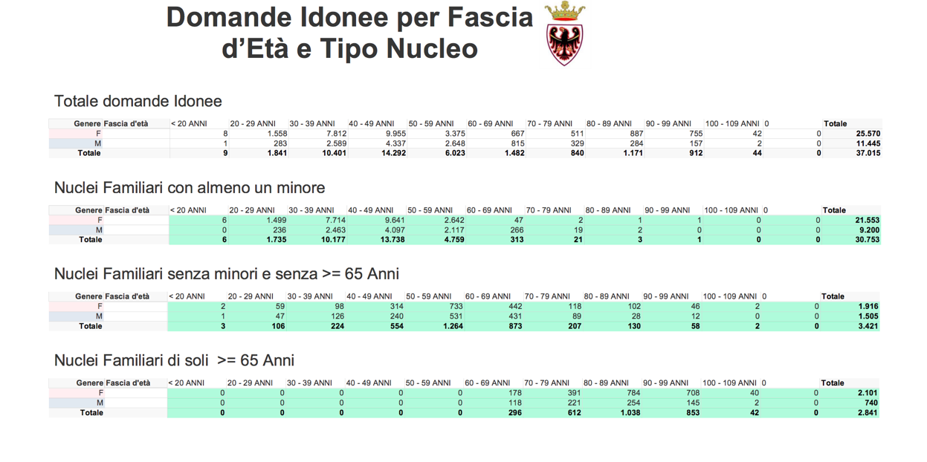

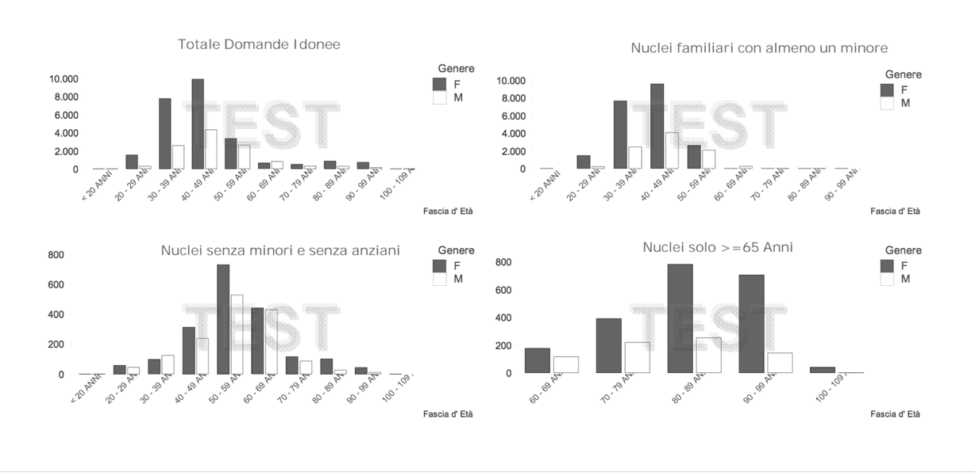

# MAPPING OF POLICY AND REGULATIONS

1) **At a provincial level**:

Support for access to sports activities for families and children in socio-economic difficulties is activated through the following tools.

***Service Vouchers*** - On the basis of the Provincial Council resolutions n. 578 of 13 April 2015, n. 2147 of 14 December 2017 and 322 of 2 March 2018 are expenditure titles granted by the Autonomous Province of Trento with the co-financing of the European Social Fund, aimed at supporting and increasing the female employment rate. They allow to buy

use educational services for the care and custody of children at accredited non-profit organizations against a personal financial contribution equal to at least 15% -20% of the nominal value of the voucher, depending on the age of the minor. The services financed must be provided in a complementary form to those institutionally guaranteed, for example due to the impossibility of accessing the municipal nursery, during extra-school hours or during holidays.

Each Voucher can have a maximum nominal value between € 900 and € 1,500 depending on income and family assets, certified by a CAF through the specific ICEF Application for Service Vouchers. They can take advantage of these vouchers

- women who are employed or who are about to enter / re-enter the labor market, or who are involved in forms and / or actions of expulsion from the labor market included in training-requalification courses aimed at actively seeking employment. In the case of a two-parental unit, both parents must be employed;

- men belonging to single-parent families.

***Citizenship Sports for All*** - Based on the Provincial Law no. 21 April 20156 nr. 4, the Province promotes the diffusion of the sport of citizenship for all through the support of initiatives that favor motor activity practiced in an organized or individual form by people of all genders and ages, even with disabilities, to encourage the correct styles of life, to develop social relations, educational training and intercultural integration, to promote gender equality and to maintain an adequate state of health. In particular:

*a)* contributes to the financing of projects to promote physical activity, including multi-year duration, presented by sports federations, associated disciplines and sports promotion bodies, also in collaboration with their affiliated associations, to encourage the growth of practitioners of different motor activities;

*b)* promotes program agreements between public and private entities aimed at identifying useful measures to promote:

- the motor activity of men and women of all ages, even with disabilities, throughout their life;

- the reconciliation of work and family care times with sporting activity and an equitable participation of women and men, also overcoming stereotypes;

- the coordinated organization of information, awareness raising and sports promotion events;

- coordination of initiatives proposed by sports associations operating in the Trentino area and their dissemination.

2) At a municipal level:

The service "Center for territorial youth aggregation" is activated by non-profit organizations accredited by the Autonomous Province of Trento on the basis of the Implementing Regulations of articles 19, 20 and 21 of the provincial law n. 13.

The service is a meeting place for the generality of minors and young people of a given territory. The operators and educators who work there play a guiding and stimulating role for approaching the practice of some sports, expressive and training activities.

Based on the Determination of the Manager no. 276 d.d. 23 August 2019 in the Municipality of Trento various accredited entities operate, in particular: the Periscopio APS Association, the Provincial Association for Minors - APPM onlus, the "Gruppo OASI onlus" Voluntary Association, the Casa Gene -ralizia of the Pious Society of Turin S. Giuseppe - Community Murialdo Trentino Alto Adige, the Kaleidoscopio Social Cooperative and the Progetto 92 Cooperative.

All these realities operate on a target that concerns all the minors and the young people of the city in an attempt to involve as many as possible but the actions they implement are not specific on the theme of sport so there is no stratified data that can frame the problem in analysis.

# STAKEHOLDERS MAPPING

Stakeholders are all those subjects, individuals or organizations actively involved in the actions of the project. The interest of the stakeholder and its potential for action positively or negatively affect the execution and progress of the project initiative.

A stakeholder is anyone who has an interest in the outcome of a project or process. Projects, especially social impact projects, usually generate a large community of interest and their reverberations can be distant. Compared to the PI.PO - Ping Pong Without Frontiers project, the identification and choice of suitable stakeholders was carried out taking into account two specific categories: those who contribute to the project (direct) and those who are affected by it (indirect).

Considering these reflection, the following stakeholders have been mapped:

|  |  |
| --- | --- |
| Professional figures in sport (coaches, instructors, trainers)  Direct Stakeholders | Susanna Valer: former Italian champion, former member of the national team and basic coach in possession of a qualification to teach table tennis.  Silvia Sveva Pianca: former member of the national table tennis team and basic coach with skills in teaching the discipline of table tennis.  Maxim Moiseev: professional federal instructor and former A2 league player, specialized in programming and accompanying young people and teenagers  Erich Schuster: international tennis-flight instructor, former Bundesliga professional instructor and former Ukrainian national team coach. |
| Educators  Direct Stakeholders | Professional educators who work at the centers of the Provincial Association for Minors - APPM onlus |
| Social workers | Social Service of Trento |
| Professional figures in health care (psychologist, doctors etc.)  Indirect Stakeholders | Sicher Chiara: Psychologist specialized in Neuropsychology, School Educator and Professional Humanistic Counselor |
| Volunteers  Direct Stakeholders | 3 Young people from the National and Provincial Civil Service working in various partner organizations  20 volunteers from collaborating realities |
| Collaborating Schools  Indirect Stakeholders | Comprehensive Institute Trento 3  Archiepiscopal College of Trento |
| Internal and external trainers  Direct Stakeholders | Gaia Tozzo - trainer, educator and business consultant regarding the personal and educational development of groups  Sandro Scarpitti - consultant in the management and organization of the company  Luciano Zanin - fundraising consultant  Sara Angheben - consultant in the field of animation for children and sports animators  Valentina Lucca - psychologist and psychotherapist regarding the relational and learning difficulties of children and with minors |
| Collaborating sports organizations  Direct and Indirect Stakeholders | ASD Table Tennis Lavis APS  Italian Sports Center CSI - Trento Committee  Italian SPort Union for All - UISP Trento  USD Polisportiva Villazzano - Trento  ASD Bolghera Sports Group - Trento  Italian Table Tennis Federation - Trento Committee |
| Collaborating non-profit organizations  Direct and Indirect Stakeholders | Periscope Association APS  Provincial Association for Minors onlus  Carpe Diem APS Association  OASI non-profit group  Murialdo Community Trentino Alto Adige  Kaleidoscope Social Cooperative  Cooperative Project 92. |

# MAPPING OF GOOD PRACTICES

Eurostat data collected since 2014 contributed to the creation of the Save The Children report "Overcoming educational poverty in Europe." According to this report, over 26 million children are at risk of poverty or exclusion in Europe. 20% of 15-year-olds in Europe live in conditions of educational poverty. In Italy, almost 39% of children are at risk of poverty or social exclusion. 12.5% ​​of children under the age of 18 are in absolute poverty. Of these, 43% have never played sports. These data indicate that poverty is a daily reality for many people in European societies. Faced with a picture of this type, on the educational and sporting level some actions have been put into practice that have highlighted the following results:

- Convey information on the evidence of the benefits of physical movement on health

- Financially support families to encourage a moment of social inclusion for the children most in difficulty

- Reinforce proactive behaviors and intervene appropriately through suitable professional figures where emotional and behavioral difficulties are observed

- Convey the sense of "doing together" and "achieving a goal"

- Create a positive environment of protection, training, education and entertainment

- To convey the typical values ​​of table tennis sporting activity, such as: discipline, respect for the rules, coexistence with one's own characteristics, functional interaction, alliance and movement.

In this regard, in the Trentino area, we can highlight the following good practices both in terms of economic support and in terms of education / sports:

Economic support for activities aimed at minors and organized both in summer and during the school period.

***The Crosina Sartori Cloch Foundation*** provides economic support to families which is carried out both for summer activities and for initiatives organized during the rest of the year.

In fact, the Foundation annually disburses - between the summer and the school period - about 50,000 thousand euros of economic aid in favor of families in difficulty, residing in Trento, to support the expenses incurred for the participation of minors in educational and recreational activities. These contributions satisfy on average about 250 families per year. To be eligible for financial support, minors must have been resident in Trento for at least one year, must attend first or second grade compulsory school and must enroll in activities promoted by organizations, associations or cooperatives in possession of a tax code and holders current account.

The support is graded according to the "ISEE" income indicator of the family unit to which it belongs, to be attached to the application. The applicant family must not have already obtained or already requested, for the same activity, the Service Voucher granted by the Province co-financed by the ESF or other public contributions. In the area of ​​Trento, with respect to the inclusion of young people and teenagers in the field of table tennis, a support has been activated by the educators of Sport Without Borders with respect to all eligible families. About 20 families were accompanied, of which over 80 percent have an ISEE value of less than 10,000 euros per year.

In the three years in which the Foundation has intervened in support of the families of the boys who played table tennis in Trento, the contributions concerned the reduction of the costs of enrollment in courses for over 50 boys.

***Training courses for volunteer sports animators***

For three years now, the Trentino Foundation for Social Volunteering has been funding the training program for sports operators called "The Academy of the Animator". The training program is aimed at volunteers who deal with animation for minors and aimed at training and enhancing the skills of those volunteers who deal with and / or who wish to deal with socio-sports animation in favor of minors from 7 to 15 years - especially those in socio-economic difficulties - providing important competences, knowledge and skills.

In 2018, 47 young people were trained, in 2019 27 young people and in 2020 26 young people.

Projects to promote the protagonism of children

The "Zone Youth Plan" is an initiative aimed at encouraging youth planning funded by the Provincial Department of Youth Policies and by local authorities in the Trentino area; it represents an innovative instrument of intervention in the territory, whose purpose is to promote and encourage local activities in favor of young people to improve their quality of life. For two years in a row, projects were carried out in the territory of the Municipality of Trento ("Ping Pong Tour" and "Street Pong") which had the aim of forming a group of young people passionate about table tennis so that they could transmit enthusiasm and competence to peers and other younger children by carrying out outdoor activities in the city parks.

Over the two years, these activities have made it possible to meet over 300 young people from the city.

***Culture and Sport for the Social***

The Cassa Risparmio di Trento and Rovereto - CARITRO Foundation recognizes social volunteering as an important part of the third sector which, alongside the world of public institutions and private activities, re-proposes civil society as a fundamental element for community development. In particular, it intervenes in order to promote social cohesion and support the protection of vulnerable social categories.

Every year it activates tenders aimed at promoting the social inclusion of weaker categories by supporting innovative projects that use languages ​​and contents of culture and / or sport with social purposes. In 2020 a network of Trentino realities won the annual tender and is preparing to develop the inclusion of youngsters in difficulty in Trentino through table tennis.

***National and Provincial Universal Civil Service***

Historically linked to conscientious objection to the military conscription, the national civil service was then formally evolved into the National Universal Civil Service (SCU), intended as an education initiative for active citizenship to help the weaker sections of the population, to promote the values ​​of peace and equality and to contribute to the social, cultural and economic development of our country. Today it has entered a new phase which has recognized, alongside its social value and active citizenship, also its training potential and approach to the world of work.

In Trento, the ASD Table Tennis Lavis APS in collaboration with Sport Senza Frontiere, has been developing a national project called "Tennistavolo Senza Confini" for two years, which annually involves 2 young volunteers who for 12 months and 25 hours a week - for a monthly check net disbursed by the State equal to Euro 439.50 - are engaged in sports entertainment activities for young people and children, taking care of creating technical training courses, introductory courses in table tennis, activities for young people, adults and the elderly, able-bodied handicapped, elementary and middle school students.

The Provincial Universal Civil Service (SCUP) of the Autonomous Province of Trento was established in 2013 with the aim of involving as many young people as possible in order to make them mature and acquire skills and grow in civil liability.

Compared to the national civil service, the provincial universal civil service introduces differences that respond to the objective of facilitating the participation of young people and making them more educational. In particular, compared to the national one, the bureaucratic-administrative management is more simplified, the duration of the projects can vary from 3 to 12 months, the minimum weekly number of hours is 30 hours and the corresponding monthly allowance is equal to Euro 600.00 gross.

In Trento, the ASD Table Tennis Lavis APS in collaboration with Sport Senza Frontiere, has been developing a project for three years called "Table tennis as an educational and social aggregation" which annually involves 1 young volunteer who for 12 months and 30 hours a week in sports animation activities for young people in difficulty with respect to the sport of table tennis.

***Trento Sports Festival***

Since 2018, every year, the Province of Trento in collaboration with La Gazzetta dello Sport, Trentino Marketing, the Municipality of Trento, the Tourist Board - APT of Trento and with the patronage of CONI and the CIP - Italian Paralympic Committee a festival that includes interviews, debates, round tables, workshops and sports themed shows throughout the city.

Alberto Tomba, Franco Baresi, Karl Heinz Rummenigge, Federica Pellegini, Edwin Moses, Paolo Rossi, Chirstian Vieri, Paolo Maldini, Tania Cagnotto, Vincenzo Nibali, Reinhold Messner, Carolina Kostner, Iker Casillas, Elisa Di Francisca are just some of the many champions they have gave life to the festival in recent years.

# ANALISI SWOT: STRENGHTS, WEAKNESSES, OPPORTUNITIES, THREATS

This analysis allows to frame the external and internal factors that act positively or negatively on the realization of the project. in particular we talk about: strengths, weaknesses, opportunities and threats.

The SWOT matrix is ​​the graphic representation on which to focus the salient points related to the project. It consists of four squares:

top internal factors (strengths, weaknesses)

below external factors (opportunities, threats)

on the left are the positive elements (strengths and opportunities)

on the right the inevitable obstacles, internal and external (weaknesses and threats)

There are no weaknesses and threats that cannot be transformed into salient features and opportunities respectively.

The strengths and weaknesses to look for in a project are:

|  |  |
| --- | --- |
| **STRENGHTS** | **WEAKNESSES** |
| A very practiced sporting discipline and at the moment it considers it among the least risky compared to the spread of Covid 19 | Minor sporting discipline are not considered as much as other ones |
| Quality of the accompanying service to families and children currently provided | Difficulty of coordination in accompaniment activities |
| Good reputation of the sporting realities involved | Difficulty in carrying out activities in compliance with current Covid19 condition |
| High satisfaction rate by of students due to the constant participation in the laboratories proposed so far | Risk of demotivation by children due to the frequent interruptions and shifts imposed by the infection |
| Quality of accompaniment activated with the support of the sending organizations | Risk of self-referential behavior by the sending entities |
| Competent and diversified operational team in terms of knowledge | Problems sharing the lines of action within the team |
| Ability to offer a clear and consistent proposal with the expectations of the target | Difficulty in making economic aid and / or incentives for families structural |

The opportunities and threats to look for in a project are:

|  |  |
| --- | --- |
| **OPPORTUNITIES** | **THREATS** |
| Calls, funding, opportunities to diversify revenue | Bureaucratic and administrative difficulties |
| Possibility of external collaborations with other public bodies and entities | Political instability |
| An opportunity to grow everyone on the level of emotional skills | Hostile environmental context |
| Opportunity to receive very high level training | There is a risk that the contents are not very interesting and that the trainers are not adequate |
| Favorable environmental context both in terms of legislation and available resources | Danger of lockdown and interruptions |