PI.PO – PING PONG WITHOUT FRONTIERS

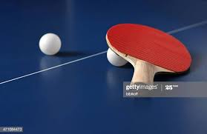 | 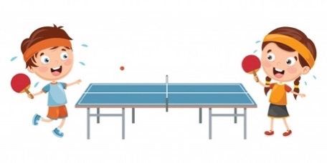 | 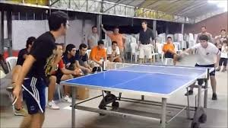

Task 2.3 - International Training LAB

DECEMBER 2021
1st-2nd-3rd

PI.PO PROJECT
INTERNATIONAL LTRAINING SEMINARS
Days : 1st /2nd /DEC

 | PI.PO TRAINING PROGRAM
 | MODULE 1 - FIGHTING POVERTY AND SOCIAL EXCLUSION THROGH SPORT
DAY 1  From 15.00 to 15.00 – 16.00 | - Erasmus+ Programme and Social Inclusion in Sport (EUROCUBE srl) – Marco Cardinaletti (Eurocube) – 15 min  - Introduction of PI.PO project (Objective/results/Activities) - Marco Cardinaletti (Eurocube) – 15 min  - Presentation of Local Ecosystem Maps (Results from task 2.1) – Susanna Valer (Sport senza Frontiere) – 30 min
 | MODULE 2 – SPORT AND SOCIAL MARGINALIZATION: SUCCESSFULL STORIES AND PROJECTS
DAY 1  From 16.00 - 18.00 | - Sports, Poverty and the Role of the Voluntary Sector. Exploring and Explaining Nonprofit Sports Clubs’ Efforts to Facilitate Participation of Socially Disadvantaged People : Successful stories from Sport Senza Frontiere – 30 min  - Presentation of Protocol for Social Inclusion and introduction to the draft of PIPO Code of Ethic for Sport (Sport Senza Frontiere) - 60 min  - Round table and discussion / Question time – 30 min
 | MODULE 3 / 4 - SPORT AND TABLE TENNIS IN CHILDHOOD AND ADOLESCENCE (THEORY AND PRACTICE).
DAY 2 – Morning  9.30-12.30 | - Brief intro on TABLE TENNIS (history and numbers)- Sabrina Moretti (Tennis Tavolo Senigallia) – 15 min  - PING PONG and social inlcusion: best experiences from TennisTavolo Senigallia – Sabrina Moretti (Tennis Tavolo Senigallia) – 15 min  - Importance of sport as means of socialization - Giuseppe Storino, sport Psychologist, Sport Senza Frontiere - 30 min  - Sport coach as educator – Marco Gritti (Psychologist) and Niki Mandolesi (Sport Trainer and Educator) – 2h
DAY 2 – Afternoon | - Introduction to the PIPO Methodology for implementing TT-Labs – Susanna Valer – 2.15 hours  - Ping Pong as anti COVID sport: interesting elements (+ ITTF tips) - Susanna Valer - 30min  - Questions and Answers – 15 min

 | PI.PO III° SC PROGRAM – Friday 3rd Dec
From 10 am to 1pm | Project Management:  - introduction to the new deadlines  - general overview of the state of art  - presentation of new GANTT  - Next Project Steps and Internal Meetings  Financial Issues:  - Budget review and internal procedures for travel r

PROJECT FACTSHEET

Acronimo | PI.PO.
Project name | PING PONG WITHOUT FRONTIERS
Programma EU | Programma Erasmus + (Sport – Small Collaborative Partnership)
Soggetto Capofila | SPORT SENZA FRONTIERE
Partners | - SPORT SENZA FRONTIERE ONLUS (IT)  - ASD Tennistavolo Senigallia (IT)  - DIA-SPORT Association (Bulgaria)  - ZAVOD APGA (Slovenia)  - A.D.E.L. - ASSOCIATION FOR DEVELOPMENT, EDUCATION AND LABOUR (Slovakia)
Durata | 24 M (01/11/2019 – 31/10/2021)
Total Budget | 69.300 EURO (di cui 60.000,00 EU Contribution)
MAIN GOAL
In the EU, child poverty has increasingly been understood as a complex, context-specific, multidimensional phenomenon, encompassing not only a lack of money and assets but also other forms of deprivation connected to children’s survival, development, protection and participation in sport activities. In 2016, around 8.5% of children in the EU lived in a household affected by severe material deprivation. In Italy, for example, almost the 39% of children are at risk of poverty or social exclusion. In Slovenia around 14,2%. In Slovakia the percentage is little bit lower, 12.4% (2017). In Bulgaria over 42%. For all of these Countries, the number of young people playing sport or who are engaged in another physical activity is decreasing year by year. Especially, if you are a young person with a migration background, access to sports becomes even more difficult. Not always it is easy to involve/reach young people and very often local sport managers have no adequate expertise to deal with people in poverty. The PI.PO. project, through a solid network of partners interested to implement locally Table Tennis Laboratories, aims at activating an international social support program for children in difficulty using the table tennis as an innovative tool for social inclusion and for enhancing positive sociality, personal and collective well-being and strengthening the sense of community as well.
By following these goal, the project is structured in order to preliminary facilitate the transnational exchange of best cases and the transfer of capacities [WP2]; to sustain the implementation of a common protocol for children/youngers throughout Table Tennis Laboratories [WP3] and finally establishing at transnational level a Sport Without Frontiers Observatory for social inclusion.
EXPECTED RESULTS/IMPACTS
- To establish a Sport Without Frontiers Observatory for Social Inclusion
- To promote networking, exchange of good practices
- To strengthen social and educational competences of trainers/coaches/managers
- To Strengthen children’s and youth’s social and educational skills
- to promote a common strategy among project partners and relevant stakeholders, through the creation of Table Tennis Laboratories
- to support the mobility of youngers, coaches, managers and staff of sport clubs and social workers
- to disseminate knowledge/drive the debate on the policies of the EU Physical Activity Guidelines

MEETING ROOM
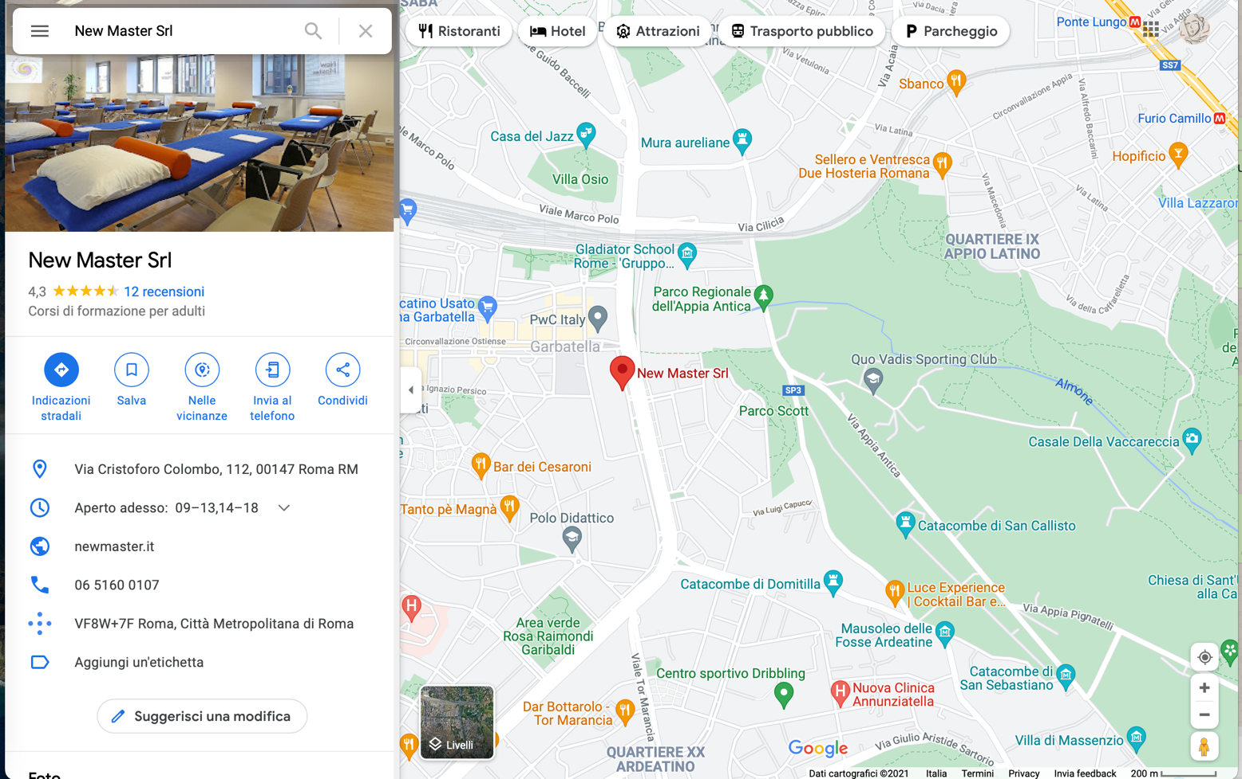
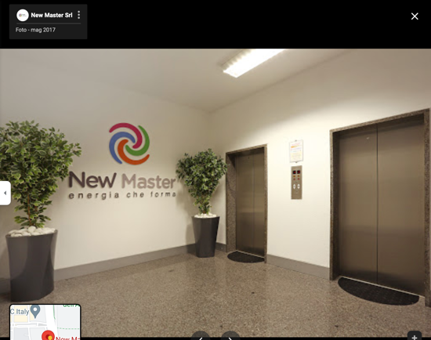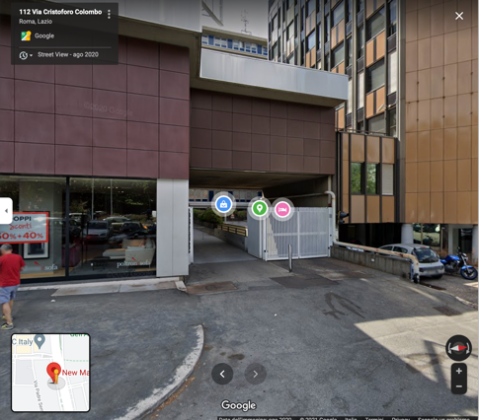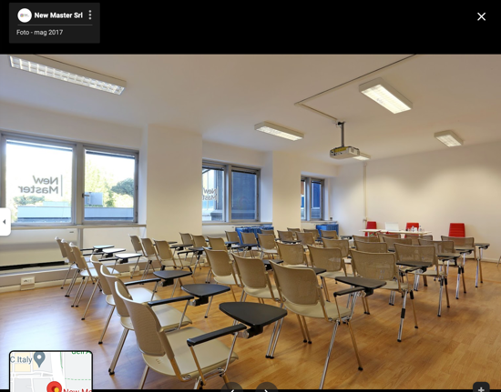

POSSIBILE PIPO HOTELS and ACCOMODATIONs

Cross Road Hotel
http://www.crossroadhotel.it/indexita.html
Abitart Hotel
https://www.abitarthotel.com/
Caravel Hotel
https://www.hotelcaravel.it/
Pyramid Hotel
https://www.hotelpyramid.it/
BV Oly Hotel
https://www.bvolyhotel.com/

