PI.PO.
PING PONG WITHOUT FRONTIERES

COMMON PROTOCOL FOR SOCIAL INCLUSION IN SPORTS
PING PONG WITHOUT FRONTIERS – PI.PO PROJECT

Content:
INTRODUCTION 3
1. GUIDELINES FOR ORGANIZING TT-LABS 4
1.1- Who is involved in the labs organization 4
1.3- How to structure the labs 4
2. GENERAL METHODOLOGY FOR THE IMPLEMENTATION OF THE TT-LABS 5
2.1 How to organize the TT-Labs? 5
2.2 Lessons Plan: PI.PO Model 8
2.3 Pedagogical Approach 14
2.4 Tips for TT-Labs organization 14
3. SURVEY FOR EVALUATION AND IMPACT ANALYSIS 16
4. LEARNING DOCUMENTATION FOR IMPROVE COACHING AND EDUCATION IN SPORT ACTIVITY 17
5. GUIDELINES FOR ANTI-COVID PROCEDURES IN TT LABS ORGANIZATION 18
6. NUTRITIONAL FACTS AND TIPS 20

INTRODUCTION
The main aim of this Common Protocol for social inclusion in sport is to improve social inclusion and integration through table tennis sport. In order to catch this important objective, this manual provides guidelines and best practices for sport clubs, trainers, coaches and managers and provides examples of fun, safe and engaging activities to ensure maximum participation for youths living in conditions of vulnerability.

The main target group of this protocol is indeed composed by children and young people who, due to their condition of social fragility and socio-economic hardship, have difficulty in accessing sports.
Children in poverty condition need a “safe” sporting environment, financially, physically and/or socially and table tennis can contribute to social inclusion, being a way to broaden own social world, meet new people and interact with other.

Thanks to the work made by the PI.PO Projects’ international partners, this Common Protocol for social inclusion in sport contains findings and results obtained by a spread research made in Italy, Bulgaria, Slovakia and Slovenia. This works were focused on policies, projects and activities that ensure social inclusion for children in difficulty using the table tennis as an innovative tool for enhancing positive sociality, personal and collective well-being and strengthening the sense of community as well.

Inside the Common Protocol for social inclusion in sport the reader will therefore find, firstly, a list of guidelines for sport clubs to foster social inclusion, based on the analysis and mapping of international best practices in projects that provides integration throughout sport (chapter 1). The second chapter is focused on methodologies for involving young athletes in sport laboratories and some examples of table tennis exercises are given. On Chapter 3 a survey format for evaluation and impact analysis is provided while in the fourth one some learning documentations for improve coaching and education in sport activity are presented. Ultimately, the last chapter is completely dedicated to Anti-covid procedures in TT-labs organization.

1. GUIDELINES FOR ORGANIZING TT-LABS
Labs should be 3 or 4 meetings with children both indoor or outdoor. Places, gyms and halls provided by stakeholders are excellent places to develop our laboratories. Groups should be structured by 8 to max 10 children and 3 or 4 tables will be needed. If not possible, it’s necessary to lower the minimum children amount.

1.1- Who is involved in the labs organization
Local sports clubs, instructors, schools, social centers and NGOs should be involved in the organization of the TT-labs.
You should look for both children to involve in the participation in labs and qualified trainers who will carry on the activities.

1.3- How to structure the labs
Labs should last minimum 1 hour and maximum 1 hour and a half and structure should be the following:
5min. à greetings and presentation of the project and lab structure (if it’s the 1st table tennis experience for them, introduce the sport and some interesting facts about it)
1 hour tt-lab example
10min. à warming up (joint mobilization, running… NO STRETCHING)
20min. à base strokes (forehand, backhand) / fun games with racket and balls (see point 2)
5 min. à BREAK
10 min. à combination of base strokes
5min. à free play
10min. à stretching and final children feedback (you can ask children if they had fun or questions that can help you improve the next lab)
If lab will last 1hour and a half, you can add 5 minutes per each section or distribute time at your discretion.

2. GENERAL METHODOLOGY FOR THE IMPLEMENTATION OF THE TT-LABS
In order to achieve the main goal of include and integrate trough sport activities children and young people who live in conditions of social fragility and socio-economic hardship is essential to organize and offer a well-planned training. Each part of the sport lesson has to be carefully prepared from a practical and a relational point of view. Working with vulnerable youngster, in fact, involves the responsibility of establish on one side an effective and empathetic relationship with them to keep participants engaged and on the other side to offer them fun activities.
This chapter will offer a guideline for trainers and coaches in order to build an effective training programme for vulnerable children and young people by also providing some tips and practical examples.

2.1 How to organize the TT-Labs?
Before starting a tennis table laboratory, is mandatory to carefully plan each phase of the class by using a standard training template such as the following:
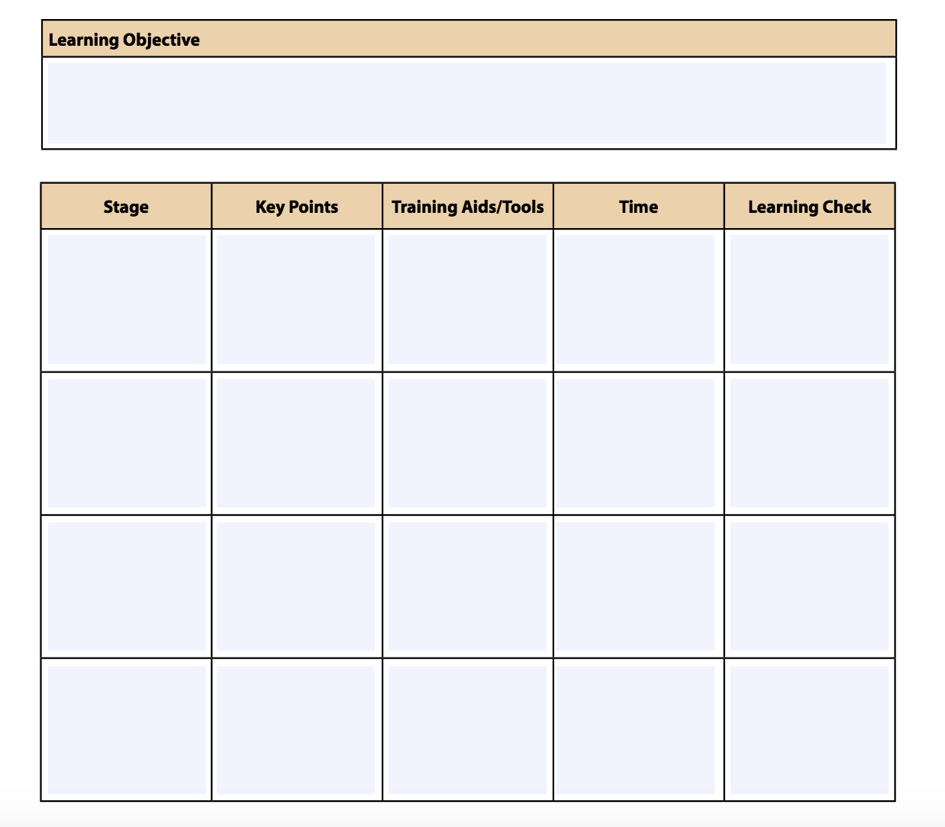

Although plan and fill out this template could take time, it helps providing an efficient lesson to children and young people, organizing material consistently over sessions and avoiding duplicating topics. It also offers a secure base from which to start build a relationship with young participant, because if the instructor has clearly in mind how to set the lesson before starting it, he has a low level of stress during it and can fully focus on children.
The first step to fill out the template is to define learning objectives for each stage of the session. The instructor have to think about what he want the trainees to learn and determine some indicators to measure the achievement of this objective. Reflect on these questions can help the coach to complete this first step:
- What are the most important concepts or skills that trainees need to understand by the end of the class?
- Why are these concepts and skills important?
- How will you know that they have understood these correctly?

The second step consists in clarifying key topics and related concepts. During TT-Labs a lot of exercises will be carried out, but is important to ensure consistency and coherence between skills and competencies required and learning objectives. In order to achieve this goal, trainers can list the main key topics and their related concepts and then group them together, for example, using an affinity diagram, to show how they are connected.
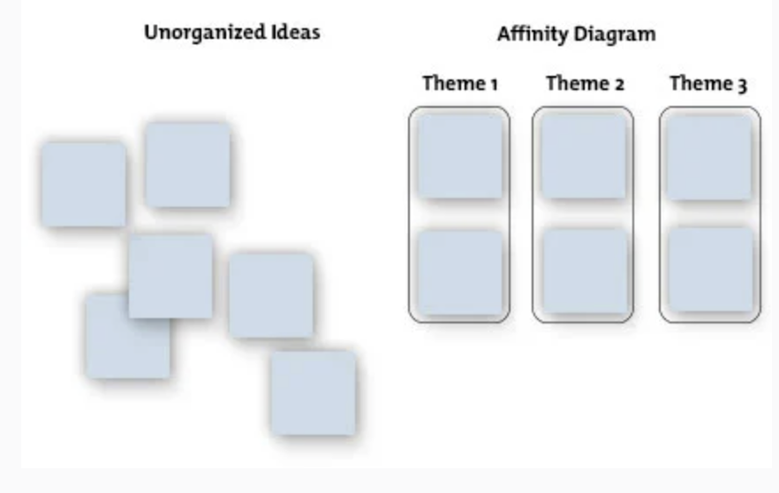
At this point, coaches can focus on planning the physical activities and games and organizing materials needed. Is mandatory to determine where the TT-Labs will be realized whether indoor or outdoor. Considering that table tennis is best played indoors when using table tennis balls, because the wind outdoors can affect the flight of the ball, is also true that organizing a Lab outdoor can help to reach a wider group of young people living in the area. Remember that Labs have to be prioritily organized in places where social exclusion is bigger risk by offering activities, for example, in:
- city squares;
- playgrounds;
- schoolyards;
- gyms;
- closed spaces;
Considering instead the materials needed, table tennis tables are not essential, because exercises can be realized even on wood tables, benches, floor, bar tables or trestle tables. Books, pieces of wood and folded paper can be also used as a net if needed. Table tennis rackets and balls are important, but larger-sized Table Tennis balls or balloons are an easier alternative. Finally, if games will be played on the floor, there can also be used tennis balls or similar.
Focusing now on games, some examples are set out below:
- RELAY RACE à 2 groups in line. Ball is in balance on racket, kids start running or walking as fast as they can to reach an established point, then they come back to their group mates to pass ball and racket. 1° group to finish wins;

- BOUNCES (exercise that helps to know the bouncing mechanism) à You will need
  - A bunch of ping-pong balls for each player.
  - Four glasses for each player.
Setting:
- Have each player stand facing the edge of a table. In front of each of them, about 40cm from the table’s edge, line up the four glasses parallel to that edge of the table.
Rules
  - Players must bounce their ping-pong balls off of the table’s surface and into the glasses in front of them. The ping-pong balls must be bounced off the table before they go into the cup — they cannot be thrown directly into the cup.
  - The first player to fill all of their cups wins!

- FUN PATH à you will need:
  - Rackets
  - A ping pong ball
Rules:
  - Players sit in circle, their legs spread, tiptoes touching, then some cm away;
  - Ball rolls on the floor, players pass the ball with the racket without making it bounce
  - If the ball exits the circle by passing the space between feet, players lose

Back to the training template, after setting the learning objective, the key points, exercises and materials is now mandatory to dedicate some time in planning evaluation tools. This helps to check if trainees have understood key points of the labs, but also to verify children’s satisfaction, skill developments, sureness etc. Reflect on these questions can help the coach to complete this step:
- Was the lab fun?
- Did the players enjoy themselves?
- What might be done to improve the session?
- Did the players participate enough?

Remember, in the assessment phase even participants could be involved by asking them what they have learned and if they have some useful feedback to improve the TT-Labs.

2.2 Lessons Plan: PI.PO Model
Let’s focus now on how to concretely organize a training session by proposing a workout model that could be taken as a reference in the implementation of the TT-Labs.
This model refers to a training session that could be realized twice a week for 1 / 1,5 hours and aimed at groups from 8 to 10 participants.
Generally speaking, each TT-Lab opens with 10 -15 minutes of muscular warm-up with exercises focused on gentle mobilization of the limbs and the back have to be explained and proposed to children and young people.
Subsequently, participants have to be grouped into 3 different categories based on their age, athletic preparation and physical predisposition:

- "Entry Level" section, normally dedicated to children, is carried out without the direct use of the tables. Session works on sustain articulated motility as a part of a preparatory path to gain confidence with the game tools and with their game-friends;
- "Multiball" section for older children and/or for those who have played the previous section for at least 2 months. The "Multiball" or "Basket" exercise is an exercise that involves children around a table (usually 2-3 for each table) and an expert who launches many balls for each child. By receiving the balls serially and continously, each child can quickly memorize correctly the right movements;
- "Advanced" section. Older children and / or those who are demonstrating ability to carry out activities also are included in schemes closer to those that may occur during the course of a game;

The technical learning model here proposed is the model of "stations": each table represents a "symbolic railway station" and the exercises with the instructors associated are different and change from table to table. Children have to move on every 10/15 minutes from a table to another (and therefore, like a train, from station to station). Such a kind of exercise allows to develop a funny and varied route, diversifying exercises, Instructors and team friends at the same time. In this way the timing of the sporting activities is maximized, the exercises are always varied, the playmates are changed each other, favouring fun, sociability and social inclusion even for those who have more difficulties

A TT-Lab’s exercise model is now given below, in order to provide a common framework shared with all the partners.
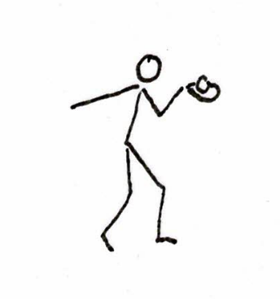
- Balancing exercise
The ball has to be placed on the top of the racket. Participants’ legs have to be bent and small movements will be made to facilitate the maintenance of the ball in balance. The duration will be about 10 minutes. The instructor can vary it, depending on the ability of the students.

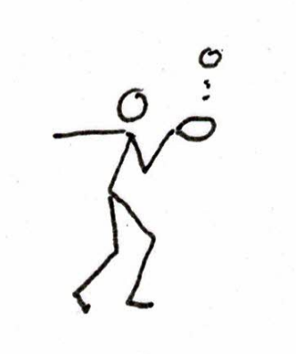
2) Dexterity exercise
The ball have to bounce on the racket. Feet can make small moves. The main goal is to give continuity up to 100 rebounds. The duration capacity depends on the age of the students. With the repetition over time, participants can exceed 1000 rebounds.

At the end of the second exercise, the students will be able to play at the table to express their spontaneous game. The instructor will have to observe participants in order to better understand their personality and their ability. The duration will be about 15 minutes.
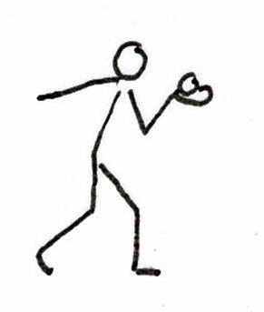
3) Movement exercise
Table tennis ball have to remain in balance on the racket, while participants walk around the area. The duration will be about 10 minutes.

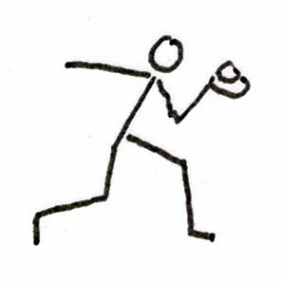
4) Running exercise
With this exercise, we move from a static harmonisation to a more complex one, that engages sight and concentration. The duration will be about 10 minutes.

After the fourth exercise participants can get back to a free game, but the instructor have to suggest them some technical variations according to the level of their play.
5) Complex harmonization exercise
With this exercise, participants experience the complex world of harmonization. Over time children and young people will run faster and faster keeping the ball in balance on the racket. Involving attention and strong concentration, the student without thinking about it will be stimulated to run stronger and stronger. This adds and increases strength. The duration will be about 10 minutes, time that the student does willingly because he is involved in the race and in the game.

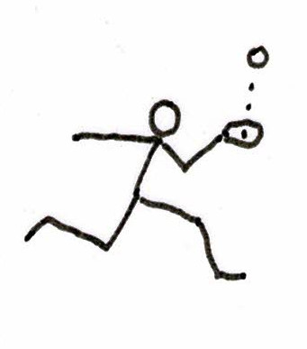
6) Slow run exercise
Now the previous exercise is repeated, but this time running with the ball bouncing on the racket.

7) Quick run exercise
With the seventh exercise performed with the ball bouncing on the racket participants completed the harmonization exercises.

General consideration
The duration of each exercise has been set at about 10 minutes. The instructor can change the time based on the need of the group. In other words, trainer can change the chronological order of the exercises. The important thing is to complete the seven stations. In addition, the stations should also be performed with the left arm. It’s up to the instructor to make all the exercises enjoyable and to check that the interest and curiosity of the students is always high. If participants’ attention fall, change the scheme with one that is more appealing may turn out to be an effective choice.
8) Leg movement exercise
This exercise can be played without the racket, especially with entry-level participants. Two players start the game: the first one has to throw the ball on his table, make it pass over the net and make it fall on the table of his opponent. This latter have to take the ball with his hand after the rebound and repeat what his opponent did. For the simplicity of the scheme, the two players can play one or more sets counting the score up to eleven points in order to ease shifts among children. The unintentional didactic aspect is that to play tennis table you need to move your legs.

9) Eight steps path
The entire path has to be played with ball in balance on the racket and knees bent with gazelle’s step. The first time, path has to be completed slowly walking, then slowly running and finally running fast.

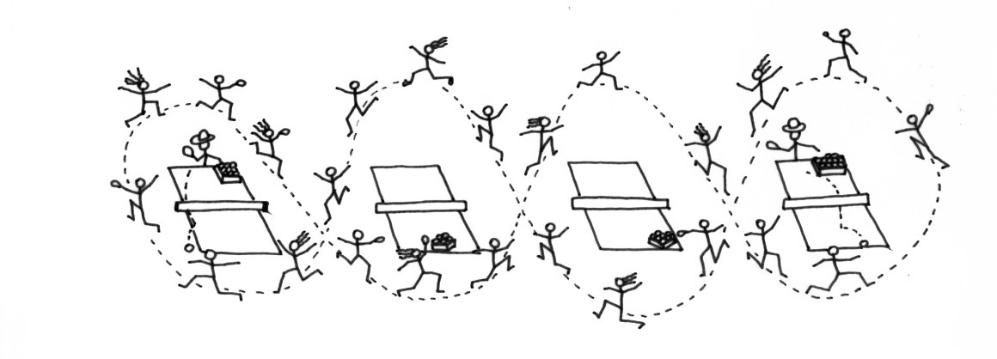
10) Double eight steps path
The path is suitable for fifteen to twenty participants. On the right table, instructor throws the ball towards the straight of the athlete, who arrives running. After hitting the ball, participants continue the race and recover the ball on the ground. Restarting the round, he has to deposit the ball in the appropriate box located on the same table. Moving on to the fourth table on the left the athlete responds with the reverse. Children have to recover now their balls by continuing the path to the initial position. The path can be repeat several times.
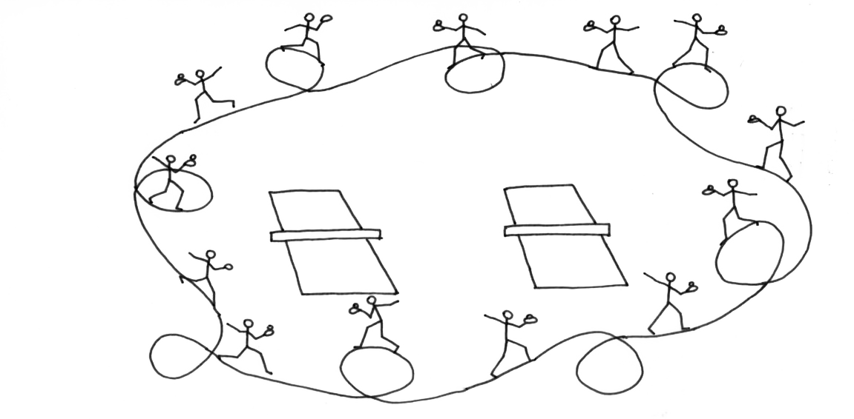
11) Balancing exercise

This path has to be completed with ball resting on the racket and kept in balance, with circular turns to the right and left.

12) Autonomy booster
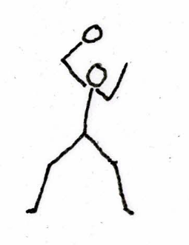
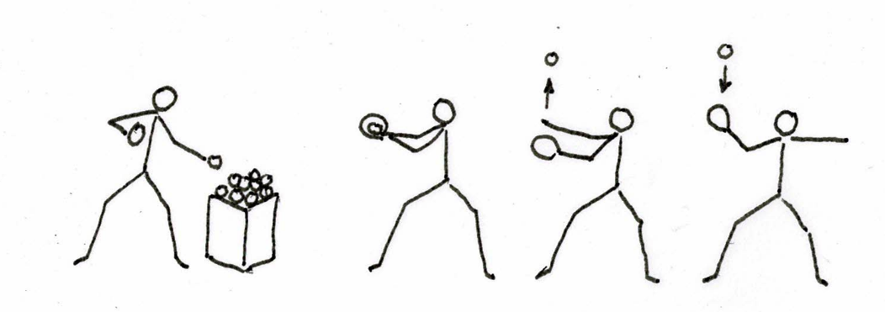

1 2 3 4 5

The pupil positioned far from the table will take the ball from the basket placed next to him (image 1), place the ball in front of the racket (image 2), throw the ball upwards with his hand (image 3), hit the ball (image 4) the goal is reaching a target on the distant table.

This exercise can be repeated by executing many strokes; top spin (images 5 and 6), high defense (image 7), push (image 8).
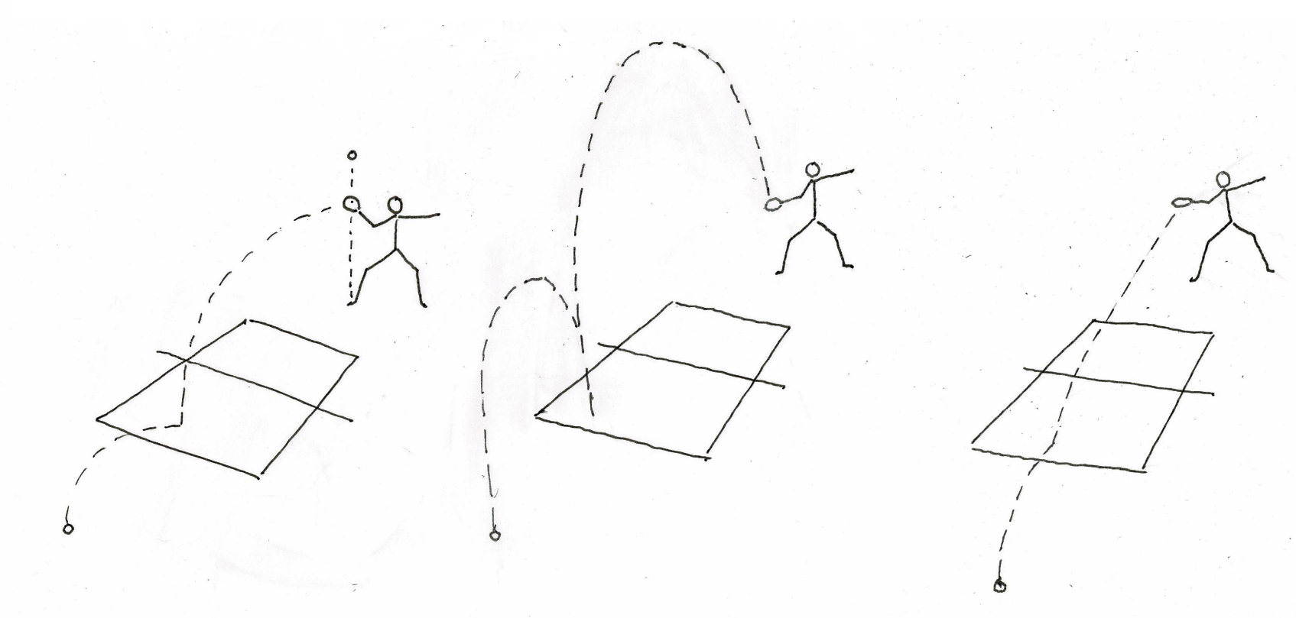

6 7 8

The coach will initially let the pupil free to experiment with shots. He will subsequently intervene with suggestions and corrections, but without depriving the student of his own spontaneity and pleasure of discovery.

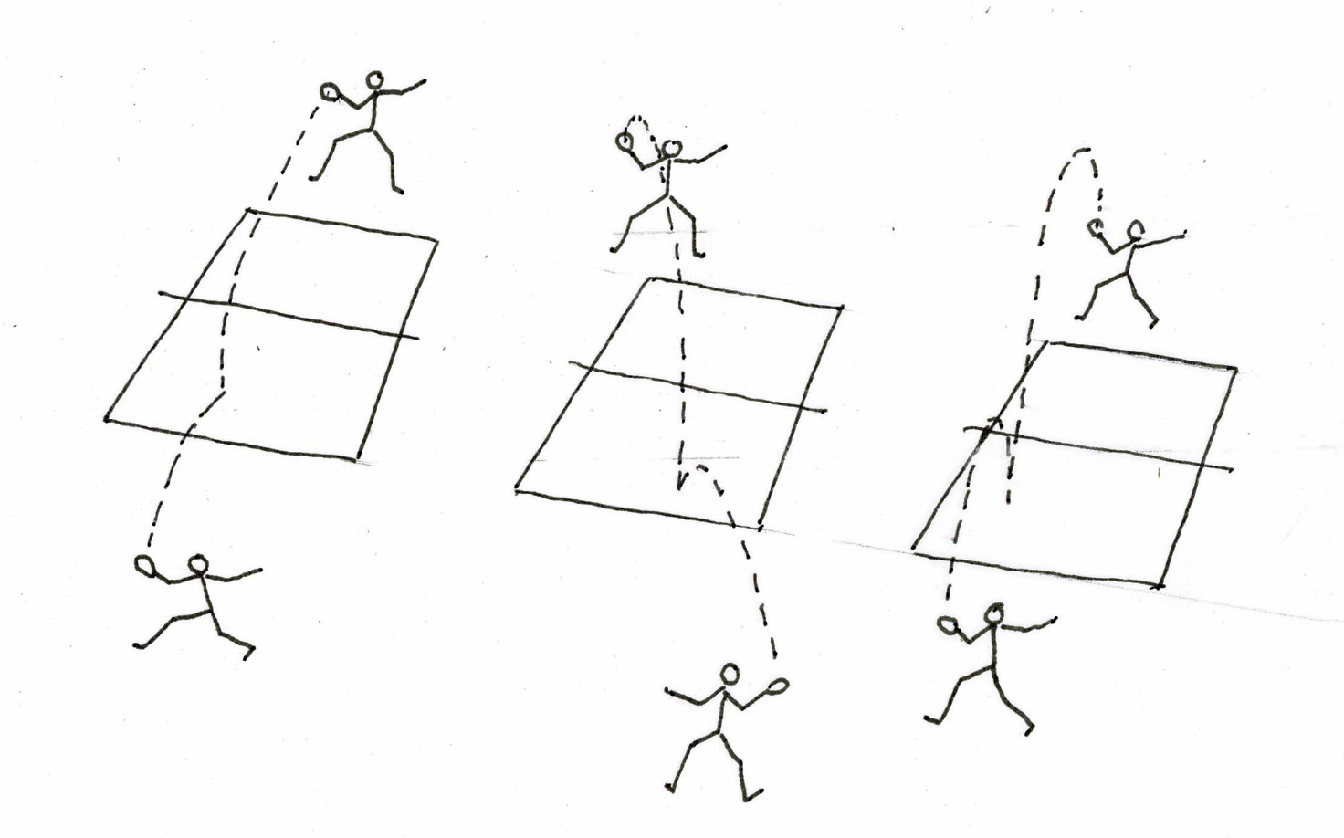
When the pupil will be ready and regular, he will be able to perform the exercise with a partner (images 9, 10 and 11).
9 10 11

After these exercises that free the gesture and the mind of the student, those who wish can start the specialization courses.
These exercises are also useful for a psycho-physical recovery linked to the pandemic.

2.3 Pedagogical Approach
Tennis Table sport makes it possible to develop athletes’ individuality, self-esteem and self-awareness in a group setting. Despite being predominantly an individual sport, ping-pong enables participants to interact with others – team fellows or opponents. Once the game starts, each set must be considered as a dialogue between two people. If one of them does not accept other’s argument, he must be able to involve his opponent in a more valid argument. This example must be taken as a method of pedagogical investigation: it helps to facilitate our observation and to identify participants’ behaviour and personality. With patience and attention, coaches have to encourage children to consider the set as a normal dialogue between two civilized people, which starts with the desire of truly understand other’s point of view without preconceptions. This is the reason why coaches must be prepared and must encourage positive socialization, especially when the target concerns young people living in conditions of vulnerability. Fragile children may have lived difficult experiences or dysfunctional relationships in their past and tennis table can help them to restore a positive balance and effectively including them in society.

2.4 Tips for TT-Labs organization
In this subchapter are reported some tips and advices useful for organizing TT-Labs:
- Duplicate games and circuits to ensure maximum participation;
- Keep instructions as brief as possible to ensure participants are quickly engaged in the activity;
- Check the playing area is free of hazards and is a safe distance away from walls and fixed objects;
- Ensure the surface is a safe and appropriate surface for the activities;
- Check there is a safe distance between groups of participants and tables;
- It is recommended that there is space of at least two metres at either end of the table for the players:
- Make sure all equipment is appropriate, safe and working correctly;
- Always check equipment that has been set up by others before you use it;
- Always provide clear instructions for the game and use of equipment;
- Instruct participants on safety when at the table: no leaning on the table;
- Ensure participants care for rackets: no picking of the rubber on the racket;
- Remind players to beware of table corners when moving around the tables;
- Make training memorable and learning fun by using different training methods;
- Alternate the pace of each session to keep trainees’ interest level high;
- Use humor to keep enthusiasm at peak levels. Avoid telling jokes, however, because humor is so subjective that someone in your audience may be offended and lose track of training for the rest of the session;
- Encourage participation by engaging participants in the learning process. In fact, try to spend close to 80% of training time on group participation. Encourage everyone in the training session to speak freely and candidly, because learning occurs most readily when feelings are involved;
- Create a win-win environment by using the training program to build the participants’ self-worth and self-esteem;
- Engage the participant by following these strategies:
  - varying voice quality and volume to suit the situation coaches can gain the participants attention, and add qualities such as excitement, concern and annoyance;
  - by maintaining eye contact, the coach can personalise things, give the impression of confidence, and add expression to the message.
  - Signal for attention: some coaches use a whistle and others use a variety of commands. Whatever the method, it should be loud, different and gain attention.
  - Silence as a signal for attention when players are expecting noise and it doesn’t happen.
  - Ask questions: using questioning and discussion techniques shifts the focus from the coach to the participant. The participant takes on some responsibility and becomes more involved in the learning process.
  - Praise and compliment: sincere and equitable praise and compliments to the group and individuals provides incentive and motivation to the participants.
  - Quality instructions: combining brief clear instructions with demonstrations enables the coach to maintain the interest of participants. One of the most difficult things for many coaches is to limit instructions to one or two key points and then return to the activity.
  - Increase participation: long lines of participants waiting for a turn, greatly reduces the opportunities for players to be actively involved and the level of enjoyment for participants.

3. SURVEY FOR EVALUATION AND IMPACT ANALYSIS
The actual achievement of the results obtained by the TT-Labs will be verified thanks to the acquisition of data during the various phases of its realization.

Regarding on-going monitoring of activities, the following instruments will be used:

- Attendance sheet: will monitor the number of beneficiaries of the activities provided and the rate of attendance of children and young people at TT-Labs throughout the entire journey;

- Detection grids: weekly, instructors have to compile a brief summary card describing the activities carried out during the trainings and report observations about the motor abilities acquired by participants (coordination, space-time orientation, muscle strength, aiming, speed of movement, ability to use the racket);

- Observational Diary: during the realization of the TT-Labs the instructors will have at their disposal a diary in which to report observations or episodes related to the affective-relational and behavioural components of each participant (sociality, capacity for cooperation, tolerance to frustration, acceptance of rules, recognition of roles);

In order to assess the social impact of the TT-Labs activities, during the first and last day of training the young participants will be subjected to a questionnaire in order to verify the initial situation and the results obtained thanks to the TT-Labs. Specifically, the following indicators will assess:
- Free time: in order to verify the effective contrast to the sense of isolation of young beneficiaries, the questionnaire will investigate the amount of weekly hours that young people spend on:
  - organised and non-organised recreational activities;
  - organised and non-organised sporting activities;
  - other activities in organised and non-organised contexts;
  - studying;
  - social networks/television/electronic games;

- Social relations: in order to verify the effective contrast to the sense of isolation of young beneficiaries and the increase of their social relations, the questionnaire will investigate:
  - The number of social relations between children and their peers in organised and non-organised contexts;
  - The number of social relationships between children and adults (parents, relatives, babysitters, etc.) in organised and non-organized contexts;
  - The amount of time spent in recreational, sports or other activities in solitude and in the presence of other people (peers/adults);

In order to obtain also quantitative data for the evaluation of motor abilities acquired by young people, during the first and last day of training young participants will have to perform simple motor exercises in order to evaluate their coordination, aim, speed and ability to use the rackets.
For example, in order to assess the aim, beneficiaries have to center with a tennis ball some concentric circles. Children will get a score based on the circle’s diameter centred (Largest circle: 5 points / Middle size circle: 10 points / Smallest circle: 20 points). Or, to assess the ability to use the racket and coordination, young people will be asked to walk along a path by playing a ball on the racket itself and the evaluator will have to score how many times the ball will fall.

4. LEARNING DOCUMENTATION FOR IMPROVE COACHING AND EDUCATION IN SPORT ACTIVITY
Good behaviour management and strategies to deal with misbehaviour are essential to carrying out a coaching session. Strategies aimed at conducting effective and safe sessions go a long way to preventing misbehaviour. The Australian Sport Commission released a handbook, which contains some valuable advices on how to manage misconduct. Some of their guidelines are reported below:
Inappropriate behaviour and/or a lack of interest and attention may be caused by:
- insufficient equipment for group size;
- limited supervision and lack of interest shown by the coach;
- activities which are slow to start, due to too much talking by the coach;
- activities that run for too long;
- children waiting in long lines for their turn;
- activities that are boring and not challenging enough;
- unclear rules and expectations;

In other words, sometimes the coach’s program, organisation or style can contribute to disruptive behaviour. These are some efficient strategies to prevent misbehaviour:
- Create a team atmosphere: be positive and encouraging and give feedback;
- Ensure children have a clear understanding of rules, routines and appropriate behaviour; Manage inappropriate behaviour as soon as it occurs;
- Understand pre-existing rules and routines, and what strategies and approaches work well with a particular group or individual;
- Learn about any children with physical, behavioural, emotional or social problems;
- Look for good behaviour and reward through praise and privileges;
- Provide fun and variety, and high levels of activity;
- Challenge more experienced children and make discrete allowances for those less skilled;
- Use inclusive coaching practices, that is, adapt and modify coaching practices to ensure all children have the opportunity to participate;
- Plan activities that follow on from each other, thus reducing waiting time;

The following advices provides a suggested routine for dealing with misbehaviour. Coaches have to be consistent and patient in following the suggestions as some misbehaviour may need time to correct.

Let’s focus now on more direct and practical tips.

When a misbehaviour presents, depending on the severity of this one, it may be appropriate to address the behaviour in front of the group to demonstrate the stantards expected. To do so, coach has to:
- Do so without delay;
- Focus on its non-verbal cues;
- Join in and partner with the misbehaving child without comment;
- Divert the child’s attention;
- Ask a skill-related question, such as: “How is that serve coming along?”
- Remind the child discretely of group rules and appropriate behaviour;
- Address the behaviour of the child, not their character;

If misbehaviour is still an issue, the coach’s next steps could be:
- Relate the problem back to team rules
- Explain how their behaviour is impacting others
- Ask the child “What are you doing?” and “Is this against the rules?” follow on with “what should you be doing?”

If misbehaviour continues, coach has to explain the consequences and:
- Be polite, calm, brief and specific
- Do not use punishment, blame, shame, sarcasm or cause pain
- Do not ignore the child
- Forgive and forget
- Remove the child from the activity: use a time-out away from other children but close enough to supervise
- Provide an opportunity for the child to re-join the group, if they agree to abide by the rules

Lastly, if the problem is not rectified, coach must refer the matter to an appropriate person (parents, legal guardians, educators, social workers, psychologists, etc..)

5. GUIDELINES FOR ANTI-COVID PROCEDURES IN TT LABS ORGANIZATION
In order to prevent and reduce the risk of contagion, it is necessary to carry out a prior analysis of the sports structure, the spaces and the environments that will be used for the running of the TT Labs. Interpersonal distance must always be guaranteed and the possibility of multiple people being present in the same environment must be minimised.

Therefore, it is necessary to review the layout of the spaces, equipment, access and exit routes and information signs relating to the facility where the activity takes place, with the aim of:
• devising a different internal movement of people, taking into account the characteristics of the structure, with new routes and flows of movement;
• identifying and differentiating, where possible, entry and exit points of the structure;

As regards access to indoor gyms and/or sports areas, the following requirements exist:
• OBLIGATION TO HAVE A COVID PROTOCOL RESPONSIBLE: The Covid Protocol Manager is given the task of carrying out specific activities of personal data processing and the correct fulfilment of health protocols. In particular, he will have to:
- Record the access of the participants by writing down their names on a special paper or technological medium daily
- Measure body temperature before they enter into the working environment in the prescribed cases;
- Obtain specific information on the state of health of the users of the laboratories (particularly the symptoms which may lead to infection with Covid-19 virus);
- Collect self-certifications from attendees
- Check the maximum number of accesses and ensure the sanitation of tools and personal distance
- Preventing access to laboratories for those who do not have the requirements
- Remove suspicious cases

• REQUIREMENT TO MAKE THE TRIAGE: i. e. hand hygiene, temperature measurement, verification of the Green Pass (if required by the national legislation in force). The attendance of all participants, both students and trainers, will be recorded daily on a dedicated paper register and / or via cloud technology tools.

• REQUIREMENT TO FILTER ACCESSES AND COLLECT SELF-CERTIFICATIONS: People over the age of 12 can only enter laboratories if they are fully vaccinated (mono or bi-dose); vaccinated for at least 15 days with the first dose; recovered from Covid in the last 6 months, not vaccinated with molecular test or a rapid antigen negative one made within the previous 48 hours) or, in case of exemption, with appropriate certification. Children under the age of 12 may access the laboratories only after the daily delivery of a self-certification filled by the operator of parental authority. Parents and/or accompanying people are not allowed to access.

• REQUIREMENT TO WEAR THE MASK: for the whole process of triage and any stop inside the locker room. It is also mandatory to wear it in the corridors and for any movement outside the own play area, as well as during breaks;

• IN LOCKER ROOMS: in addition to keeping the mask to cover your nose and mouth, it is necessary to stay as little as possible inside and to bring inside the gym, in your own playing field, only a bottle and a towel. It is also required to observe a minimum of 1 metre of interpersonal distance, keeping as much distance as possible between one station and another. You must respect the maximum limit of 10 people inside the locker room;

• IN THE GYM: each playing space must have a minimum area of 4. 5 x 9 mt. which must be clearly delimited by boundary/separation elements or barriers (for example, if the gym/room has an area of 200 mq, a maximum of 4 tables can be placed).

In any case, during the game, a distance between the players must always be maintained never less than 2 meters. Only players (2 or 4, in the case of doubles) and, in case of competitions, the jury can be present in the play area. Playing areas must be equipped with tables and all other necessary materials and then, if possible, always disassembled by the person/people assigned for this purpose. Such people have to carry out the related operations by wearing a surgical mask and always washing their hands with soap and water (or disinfectant gel) before and after setting up/decommissioning the gym.

SANITATION

Sanitation of the following materials must be carried out both at the beginning and at the end of each LABORATORY:
• TABLE: both the surface and the sides. (If necessary, when using the bar on which the towel is put).
• BALLS: and the basket containing them must always be properly sanitized.
• BALLS COLLECTOR: especially the handle of this.
• BARRIERS: as they are only touched at the top, proper care must be taken when cleaning this part.

6. NUTRITIONAL FACTS AND TIPS
It is well known that sport is good for children, as well as confirmed by many scientific studies and well known by all parents.
The World Health Organization recommends that children and adolescents, aged 5 to 17, practice at least 60 minutes of moderate to intense aerobic activity every day. In developmental age, a sedentary lifestyle can lead to overweight and obesity so sport is welcome, but parents should not allow children and adolescents to eat much more than they should because they play sports, and should oppose the idea that there are miraculous foods or supplements that help to become Superman and win the race.
The varied and balanced diet is more than enough for the little athlete to become a great athlete. In short, physical activity improves the psychophysical well-being of children and adolescents is important for proper physiological growth as it promotes the development of motor and intellectual skills, strengthens muscles and bones and increases good mood.

Why is alimentation important?
The energy needs of children (growth and maturation of organs and systems) are quite high, without an adequate supply of energy the child can feel tired and reduce both strength and intellectual abilities. The calorie intake of macronutrients (carbohydrates, proteins and fats) is only one of the aspects to be taken into consideration, nutrition must be varied and balanced in macro and micronutrients (vitamins and minerals) so that children can take all the substances from food they need, even when they play sports.
If the diet does not provide all the nutrients according to the daily needs of different ages and the energy intake is low, the body mainly uses lean muscle mass proteins as an energy source, reducing muscle mass with various negative effects including which a decrease in metabolic activity. In the absence of energy, weight is reduced together with lean mass, increasing fat mass proportionally and, consequently, increasing the risk of becoming overweight or obese when physical activity ceases or reduces.

Proportions: macronutrients and micronutrients
Children have different energy needs for sex, age, weight and obviously physical activity and sport levels. Within a correct and balanced diet, calories must come from macronutrients in this proportion:

55-60% from carbohydrates:
cereals in general, bread, pasta, rice, potatoes and fruit as well as cooking sugar (sucrose or cane) which should be used in moderation (including sweets that contain it) and honey.

10-15% protein:
milk and dairy products, meat, fish, eggs and also proteins of vegetable origin contained above all in legumes, as well as in cereals.

25-30% from fat:
considering both the visible and invisible ones of foods of animal origin and those used for seasoning, including extra virgin olive oil, while butter and cream should be taken in moderation.

Micronutrients:
vitamins and minerals must be taken in compliance with the reference daily intake needs (LARN - Nutrient Reference Intake Levels) which vary according to gender and age, for example: the need for calcium from 5 to 17 years varies from about 800 mg to 1,500 per day, Vitamin A between 400 and 700 mcg, B12 between 1 and 2 mcg (the list is long and complex so it is good to talk to your pediatrician).
• If children adopt a varied diet from day to day, eating fruit and vegetables of all colors in adequate portions, milk, meat, fish, etc., they will have excellent opportunities to meet the needs of all the micronutrients necessary for their body, even when they play sports.

The distribution of meals:
Following the guidelines of the SINU (Italian Society of Human Nutrition), for example 10-year-old children (boys and girls) with a weight of about 35 kilos and an average activity (playing, studying, etc.) should consume about 2300 Kcal per day. If they do sport, the necessary calories must be higher, but proportionate to the intensity of the sport and the duration. Sports teachers and instructors are able to indicate average values ​​of energy expended so that a parent can adjust.
A first good habit, valid for everyone, is to try to divide the calories from the 5 meals of the day into these proportions:
Breakfast 25%, mid-morning 5%, lunch 35%, snack 10% and 25% at dinner.
If, on the other hand, children play sports, the subdivision will be made according to the training time:
Training in the early afternoon:
Breakfast 20%, mid-morning 15%, lunch 20%, snack 10% and 35% at dinner.
Training in the late afternoon:
Breakfast 20%, mid-morning 10%, lunch 30%, snack 10% and 30% at dinner.

What to eat (examples):
-Morning breakfast:
milk, yogurt, cereals (bread, rusks, corn flakes) but also donuts and homemade biscuits with low sugar content, fresh fruit or juices, water.
-Mid-morning snack:
Sweet or savory, bread and jam and a glass of milk, milk and fruit smoothies, or a fruit.
-Lunch:
a first course of pasta, but also legumes and pasta, vegetable soups with pasta. A second course based on meat, fish, a side dish of vegetables dressed with olive oil and lemon (lemon promotes the absorption of the iron contained in the vegetable) fruit.
-Snack:
can have the same snack foods.
-Dinner:
dinner must be less abundant than lunch and an opportunity to alternate foods that were not eaten during the day; however, it must contain a portion of vegetables and fruit.
Meal times:
It is necessary to establish at what time the physical effort will take place, because physical activity should not take place during digestion in order not to cause gastrointestinal problems, and, in particular before a competition or intense training, energy must already be available.

Time for digestion:
It takes about 60 minutes for carbohydrates, 90-120 for proteins, 3 hours for fats.
Children feed on all three nutrients it is therefore better to stick to the maximum time to make all the energy of the nutrients available for use, especially before training.
If there is no time for complete digestion, you can adjust by following these precautions:
- Eat slowly and chew very well because the first digestion takes place in the mouth and saliva begins to digest the starches contained in complex carbohydrates.
- Start the activity no earlier than 60 minutes, minimum time.
- The meal before training must mainly provide carbohydrates and proteins and low fat: partially skimmed bread, pasta, milk and yogurt, raw low-fat condiments, and foods such as meat without visible fat or fish even with visible fat.
- If the meal was less than the norm and the training ends at the time of the snack or meal, the diet can be increased.

Water:
Adolescents and children tend to accumulate heat from the surrounding environment more than adults also because they may have less sweating. To prevent dehydration and heat stress it is good that they take an adequate amount of water, fresh fruit, juices throughout the day, (avoiding or limiting the intake of sugary drinks, colas, carbonated) and especially before, during and after physical activity.
It is not true that you should only drink before and after the activity. You must also drink during the activity itself, especially if in a climatically unfavorable environment. Let's remember to respect the rule that can vary from 100 to about 250 ml of water every 15 minutes to allow proper emptying of the stomach.

(https://www.educazionenutrizionale.granapadano.it/it/stile-di-vita/articoli/attivita-fisica/lalimentazione-per-i-bambini-atleti/)

